Diversity for a Better Tomorrow

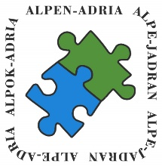
Strategy of the Alps-Adriatic geographic area
2019-2027 (SAA-2027)
Varazdin, February 2019

DOCUMENT VERSIONS

Version of the document | Changes in the document
1.0 | Initial version of the document
1.1 | Added information form VAS County and the analysis of the development strategy of the Primorsko – Gorski Kotar County
1.2 | 2nd version – comments included, new document name incorporated, Carinthia added.
1.3. | Replaced phrase “partner region” with the phrase “member”
1.4. | Added chapters related to monitoring and evaluation, indicators and connection with TCP-s  Added small scale projects into priority 2.3


Diversity for a Better Tomorrow

FOREWORD

I am very pleased to present with you the Strategy of the Alps-Adriatic geographic area 2019 – 2027. This document provides solutions that are completely re-formulating the joint development of the Alps – Adriatic Region by establishing one common goal, basic principle and implementation mechanisms. This will enable the Alps – Adriatic region to tackle joint development challenges and provide innovative solutions based on the stimulation of internal territorial potentials and mechanisms based on the diffusion of development from stronger centres to the entire region.
The Strategy of the Alps-Adriatic geographic area 2019 – 2027 is oriented at all Alps-Adriatic regions, members of the Alps – Adriatic Alliance. It focuses on the strengths and makes use of the opportunities in order to level out development gaps and push the development of the region forwards. Such approach allows for the exploitation of the potentials and insufficiently used resources.
The methodology used in order to create this Strategy will ensure greater consideration of specific needs and potentials of individual members inside the Alps Adriatic area. At the same time, it integrates the application of newest development trends and tools in the planning process. This enables improved quality and streamlining the achievement of set goals.
With this Strategy, AAA members have a solution that is tailored to their needs but it also respects the transnational features of development.
Adoption of this document crowns the one-year work effort of all AAA members. In the last 40 years of the Alps-Adriatic cooperation, states and regions have proved that cooperation and networking can only add to a better mutual understanding between people living so close to each other. Borders and walls could not prevent people from exchanging experience and learning from each other. In the following period, one of the goals should be a more intensive joint use of EU funds. This short analysis, which is based on the existing strategic documents, is only an orientation tool, a compass which will show us what direction we are heading to.

Therefore I would like to express my appreciation and gratitude to all those that contributed to the creation of this Strategy. I am sure that this Strategy will ensure a strong cooperation of all AAA members as regards to the achievement of ambitious goals set up in this strategy. As well, I am confident that the future will bring visible results to our joint efforts to strengthen the whole Alps – Adriatic region, ensuring this competitiveness and recognition not only on the EU level, but also on the global.

Radimir Čačić,
Chair of the Alps-Adriatic Council

CONTENTS

1. PURPOSE AND METHODOLOGY 10
1.1. INTRODUCTION 10
1.2. METHODOLOGY 10
1.2.1. Step 1 Agreement 11
1.2.2. Step 2 Questionnaire 11
1.2.3. Step 3 Analysis 12
1.2.4. Step 4 Draft 13
1.2.5. Step 5 Final version 13
1.3. FINDINGS 13
2. MEMBERS 15
2.1. BURGENLAND 15
2.2. CARINTHIA 17
2.3. ISTRIA COUNTY 19
2.4. KOPRIVNICA - KRIŽEVCI COUNTY 22
2.5. KRAPINA - ZAGORJE COUNTY 25
2.6. MEDJIMURJE COUNTY 27
2.7. SLOVENIA 29
2.8. STYRIA 34
2.8.1. Liezen Region 34
2.8.2. Obersteiermark Ost Region 35
2.8.3. Obersteiermark West Region 36
2.8.4. Oststeiermark Region 36
2.8.5. Südoststeiermark Region 37
2.8.6. Südweststeiermark Region 37
2.8.7. Region Steirischer Zentralraum 38
2.9. VARAŽDIN COUNTY 38
2.10. VAS COUNTY 40
2.11. PRIMORJE – GORSKI KOTAR COUNTY 42
3. JOINT AREAS OF INTEREST 44
4. VISION AND STRETEGIC OBJECTIVES 49
4.1. VISION 49
4.2. STRATEGIC OBJECTIVES 49
4.3. DEVELOPMENT PILLARS 50
4.4. INTERVENTION LOGIC 51
5. SAA-2027 AGENDA 53
5.1. COMMUNITY FOCUSED GROWTH 53
5.1.1. Support thriving civil society 53
5.1.2. Further develop and integrate the health and social care systems and address the social and economic causes of disadvantage 54
5.1.3. Using natural and cultural assets and valorisation of the potential of natural and cultural heritage 55
5.2. COHESIVE REGIONAL DEVELOPMENT 56
5.2.1. Stimulate local private sector to maintain and create employment 57
5.2.2. Improve public and private connectivity and mobility 58
5.2.3. Strengthen community cohesion 59
5.3. KNOWLEDGE, SKILLS AND ABILITIES 60
5.3.1. Ensure inclusive and accessible quality education and promote lifelong learning opportunities for all 61
5.3.2. Develop, maintain and use workforce skills 62
5.4. SUSTAINABLE ADAPTABILITY 63
5.4.1. Enable access to affordable, reliable, sustainable and modern energy 64
5.4.2. Adopt smart solutions to the management of resources to achieve economic, environmental and lifestyle improvements 65
6. HORIZONTAL AREAS 67
6.1. RESEARCH, DEVELOPMENT AND INNOVATION 67
6.2. PUBLIC ADMINISTRATION 68
7. INDICATORS 69
7.1. GENERAL INFORMATION ON SELECTED INDICATORS 69
7.2. INDICATOR FRAMEWORK 71
8. MONITORING AND EVALUATION 73
8.1. INDIVIDUAL PROJECT LEVEL 73
8.2. GENERAL STRATEGY LEVEL 73
8.2.1. Evaluation of the indicators 73
8.2.2. Evaluation of the SAA-2027 document 74
9. CONNECTION TO TCP-S 75

TABLE OF PICTURES

Picture 1: Steps in the creation of the SAA-2027 10
Picture 2: Initial Questionnaire Example 12
Picture 3: The Burgenland Region 15
Picture 4: Strategic Areas in the Entwicklungsstrategie Burgenland 2020 15
Picture 5: The Carinthia region 17
Picture 6: Strategic objectives in the Strategische Landesentwicklung Kärnten STRALE 2025 18
Picture 7: The Istria County 19
Picture 8: Vision and Strategic Goals of the Istrian County development 20
Picture 9: Koprivnica – Križevci County 22
Picture 10: Development vision and goals of the Koprivnica – Križevci County 23
Picture 11: Krapina – Zagorje County 25
Picture 12: Development vision and goals of Krapina-Zagorje County 25
Picture 13: The Medimurje County 27
Picture 14: Development vision and goals of the Medjimurje County 27
Picture 15: NUTS 3 Statistical regions in Slovenia 29
Picture 16: Development vision and goals of Slovenia 30
Picture 17: The Styria State 34
Picture 18: Development goals of the Liezen Region 35
Picture 19: Development goals of the Obersteiermark Ost Region 35
Picture 20: Development themes of the Obersteiermark West Region 36
Picture 21: Strategy themes of the Oststeiermark Region 36
Picture 22: Development action fields of the Südoststeiermark Region 37
Picture 23: Strategic goals of the Südweststeiermark Region 37
Picture 24: General development objectives of the Steirischer Zentralraum Region 38
Picture 25: Varaždin County 38
Picture 26: Vision and development goals of Varaždin County 39
Picture 27: Vas County 40
Picture 28: Development goals of the Vas County 41
Picture 29: Primorje – Gorski Kotar County 42
Picture 30: Development vision and goals of the Primorje – Gorski Kotar County 42
Picture 31: Comparison of members 44
Picture 32: Comparison of the population in the Alps – Adriatic region 45
Picture 33: Administrative comparison of the members 46
Picture 34: Common areas of intervention 48
Picture 35: Vision and strategic goals of the SAA-2027 50
Picture 36: Development pillars of the SAA-2027 51
Picture 37: Representation of the development pillars in the Strategic goal 1 53
Picture 38: Representation of the development pillars in the Strategic goal 2 57
Picture 39: Representation of the development pillars in the Strategic goal 3 61
Picture 40: Representation of the development pillars in the Strategic goal 4 64
Picture 41: Horizontal areas 67
Picture 42: Indicator selection criteria 69
Picture 43: Types of indicators 70
Picture 44: Currently established TCPs in the Alps – Adriatic Alliance 75

TABLE OF TABLES
Table 1: Vertical intervention logic of the SAA-2027 52
Table 2: Defined indicators per priority 72
Table 3: Responsibilities of TCPs accross the SAA-2027 priorities 76

1. PURPOSE AND METHODOLOGY

INTRODUCTION
The presented SAA-2027 constitutes a document which defines the priorities, goals and measures as regards the Alps – Adriatic region in order to achieve the strategic objectives set out on the transnational level.
This Strategy sets outs the objectives of the joint transnational development policy, combining the objectives identified by each member. In order to achieve complete compliance with the development needs of the members, the SAA-2027 has an explicit territorial focus.
The objectives defined in the SAA-2027 ensure efficient usage of identified specific territorial development potential for the purpose of achieving long – term transnational objectives.

METHODOLOGY
This Strategy has been created jointly by all members of the Alps – Adriatic Alliance under the leadership of the Public Institution for the Regional Development of Varaždin County, which performs also the role of the Regional Coordinator for Varaždin County in terms of regional development and which is in charge of creation and implementation of strategic documents.
During this process, a few steps have been undertaken:
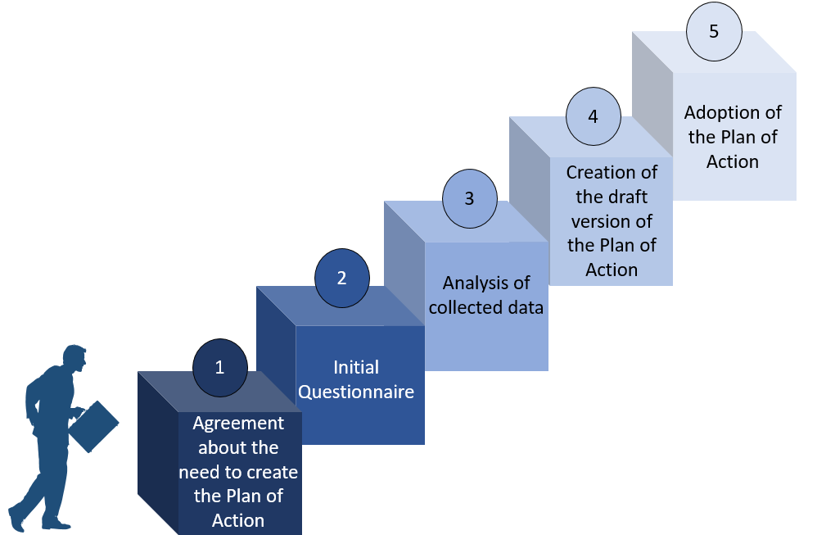
Picture 1: Steps in the creation of the SAA-2027

Step 1 Agreement
Members of the Alps – Adriatic Alliance agreed during the workshop “The future and strategic goals of the Alps – Adriatic Alliance” (Varaždin, on the 20th – 21st February) that there is a significant need to create a joint strategic document / action plan, which will help them to identify main strengths and opportunities which are characterizing the Alps – Adriatic region on the whole. In the era when many interregional organisations exist, it is crucial to know one’s own strengths and weaknesses, in order to know the strategic goals and joint points of development, and thereby contribute to performance of an organisation with the final aim to help the citizens living in the area covered.
For a leader of this process members jointly appointed the Varaždin County regional coordinator.

Step 2 Questionnaire
Based on the results of the workshop, the representatives of the regional coordinator created the initial questionnaire, which served as an initial data source for the creation of the strategical development document for the Alps – Adriatic region. The questionnaire has been sent to the Alps – Adriatic Alliance members on the 4th of April 2018.
The questionnaire has been divided into following sections:
- Initial contact data
- General data about the member
- General strategic documents of the member
- Sectoral strategic documents of the member
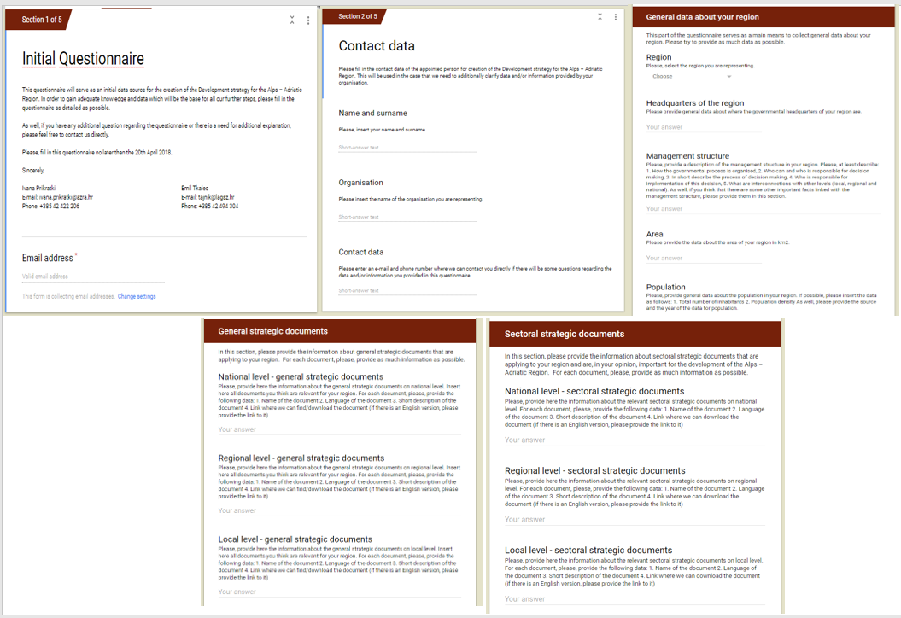
Picture 2: Initial Questionnaire Example

Step 3 Analysis
Based on the data collected via Initial Questionnaire, the regional coordinator of Varaždin County implemented the analysis. The analysis concentrated mostly on general joint characteristics of the Alps – Adriatic region, such as area, population, governmental structure, GDP. Also, based on the documents provided by the AAA members, missions and visions of the general development documents as well as the priorities, goals and strategic areas contained in these documents have been analysed. Since these components have been defined based on the SWOT analysis implemented by the expert groups tasked to create these strategic documents, this seemed as the most appropriate approach since not all SWOT analyses have been available at the moment of the SAA-2027 creation. Furthermore, the missions, visions and development priorities and goals of each member have been compared in order to identify joint features, strengths and advantages of the Alps – Adriatic as a whole, but also to identify the most urgent needs of the area that could be tackled throughout the cooperation inside the Alps – Adriatic Alliance.
Here it is important to mention that, during the creation of this analysis, only members that submitted the questionnaires have been included, and they are also represented in the Chapter 2 of this Strategy.

Step 4 Draft
Based on the results of the analysis, identified potentials and needs, a draft SAA-2027 has been created. The Plan of Action was aligned with the EU programming period; therefore, it covers the period from 2019 until 2027.

Step 5 Final version
The first draft version of the SAA-2027 has been presented to the members of the Alps – Adriatic Alliance during the workshop held in September 2018. During this workshop, the members of the Alps – Adriatic Alliance discussed about the SAA-2027, suggested the changes and adjustments. The final version of the SAA-2027 on political will be adopted in the first half of 2019.

FINDINGS
The comparison of different strategical development documents has shown that the priority areas are diverse and address requirements to benefit the Alps – Adriatic space, at the same time strengthening and diversifying the economy, natural and cultural heritage.
This Strategy aims to forecast the complexity of future challenges for the Alps – Adriatic region and to provide a cohesive set of agreed priorities. After the analysis of the collected and available data, the following joint priorities can be defined:
- Competitive region – to foster comparative advantage of regionally significant industry
- Connected region – to increase the interconnectivity of the region
- Region of wellbeing – to enhance the wellbeing of inhabitants in the region
- Region of liveability – to protect and enhance the appeal and lifestyle of the region

These four priorities have been identified based on a multitude of needs, demands and plans co-existing and competing in the Alps – Adriatic region and they allow the Alps – Adriatic Alliance to unite the regions’ development and to encourage the investments and actions to be directed where they will have greatest impact on the prosperity of the whole region. This Strategy outlines aspirations and strategic directions, as well as comparative advantages and community needs of members in the Alps – Adriatic area.
The responsibility for monitoring the SAA-2027 rests with the Steering Committee. However, the success of the SAA-2027 relies on the efforts of the AAA members, as well as on many organisations including local government, industry, non-for-profit groups, community organisations, tourism and culture stakeholders, other stakeholders and project owners.
While designing the SAA-2027, great attention has been given to the fact that the SAA-2027 should complement other relevant plans of members in order to achieve their synergy and to contribute to the further development of the whole Alps – Adriatic region.

MEMBERS

BURGENLAND
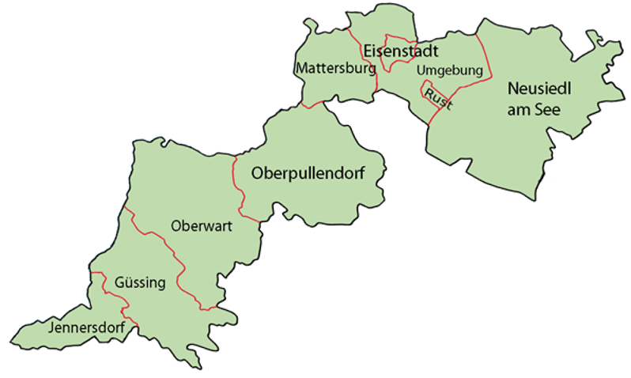

Picture 3: The Burgenland Region

The Burgenland Region covers the area of 3.961,80 km² and it is divided into 7 districts. In these districts there are 291.942 inhabitants that are living in 171 local communities.
For the Burgenland Region, the Entwicklungsstrategie Burgenland 2020 has been identified and analysed as a main document that guides the development of the Burgenland. This development strategy is divided into five strategic areas:
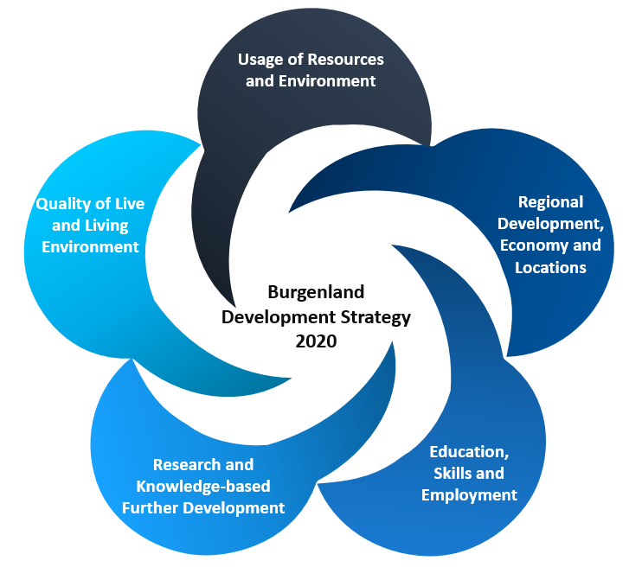
Picture 4: Strategic Areas in the Entwicklungsstrategie Burgenland 2020

Usage of Resources and Environment predicts the usage of regional resources, mostly throughout the usage of local energy sources and resources, which will ensure lower footprint without negatively affecting the life quality of inhabitants and without having a negative impact on other economy branches. This strategic area is divided into three goals:
- To foster energy conservation, energy efficiency and CO2 emission avoidance and to define them as the topics of overriding importance
- To further upgrade the production of energy from renewable sources in the region
- To support broader thematic cooperation and synergies in the area resources and nature – energy – knowledge – culture

Regional Development, Economy and Locations as a strategic area is directed towards establishing high availability of sustainable qualified jobs and employment for the inhabitants and thus increasing the life quality in Burgenland. Furthermore, indirectly, this would lower the brain drainage and the migration tendencies. This is planned throughout the following goals:
- To encourage enterprises and industries with the growth potential in the Region
- To support regional differentiation of location development

Priority Area Education, Skills and Employment defines education, lifelong learning, continuing education and vocational training on all education levels as main pillars for adequate and attractive employment in the region. Thereof, under this strategy area the following goals have been identified:
- Further development of qualification and employment while taking into account the regional demand for jobs
- To broaden decentralized provision of education – using knowledge and lifelong learning as a societal and economic potential

Research and Knowledge-based Further Development defines further development and exploitation of research and development as a pillar to increase the qualifications and enhance know-how, which enables the implementation of innovation, research and development. As well, it identifies that this, indirectly, can have an impact on the economy and competitiveness of the region. Furthermore, it identifies resource efficiency and renewable energy as the main topic that connects research, environment and development of location. It is planned that this will be achieved throughout the following goals:
- To further develop resource efficiency, resource utilization and new energy technologies throughout research
- To enhance the potentials in the field of research, innovation and know-how
- To use research and innovation through cooperation as corporate and business capital

Quality of Life and Living environment is directed towards the preservation of a healthy environment through sustainable usage of resources, improvement of the living quality by opening adequate jobs and creating appropriate training and through the support of social freedom and regional identity. In order to achieve this, the strategy defines following goals for this strategic area:
- High quality of live for the population
- Managing social challenges
- Mobility, transport and supply infrastructure
- Cooperation and regional collaboration

CARINTHIA

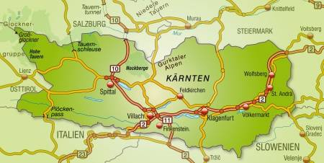
Picture 5: The Carinthia region

Carinthia is the southernmost province of the Republic of Austria. The state capital is Klagenfurt am Wörthersee. Carinthia borders on the province of Tyrol to the west, Salzburg to the north, Styria to the north and east, and Italy and Slovenia to the south.
Carinthia covers the area of 9.535,79 km² and it is divided into 10 districts. According to the census in 2015, in these districts there are 557.371 inhabitants that are living in 132 municipalities.

For the Carinthia, the Strategische Landesentwicklung Kärnten STRALE 2025 has been identified and analysed as a main document that guides the development of the Carinthia.
Carinthia development strategy is divided into five strategic areas:
- Economic capital
- Education Universities Reinforce
- Research - Expand cooperation between science and industry
- Innovation - broadening the innovation base
- Social capital
- Future-oriented education system
- Best health and care provision
- Responsibility for the weaker
- Cultural capital
- Cultural and linguistic diversity
- Science and art
- Collaboration in the AA room
- Natural capital
- Nature & Environment
- Natural resources
- Renewable energy
- Quality control
- Transparent policies
- Public finances
- Modernization of administration

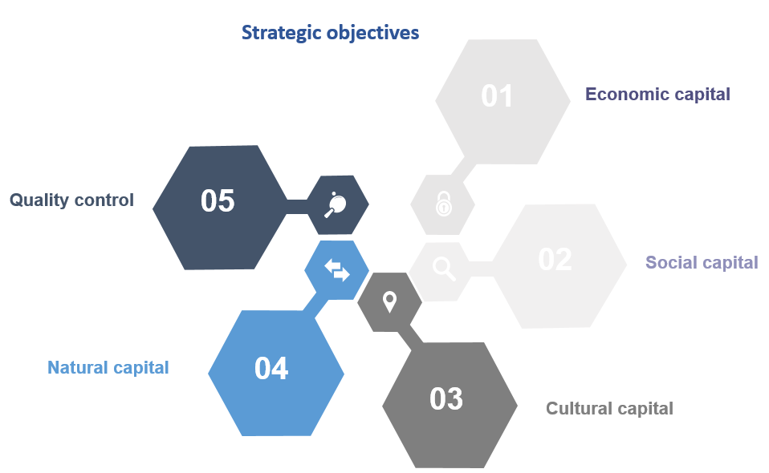
Picture 6: Strategic objectives in the Strategische Landesentwicklung Kärnten STRALE 2025

ISTRIA COUNTY

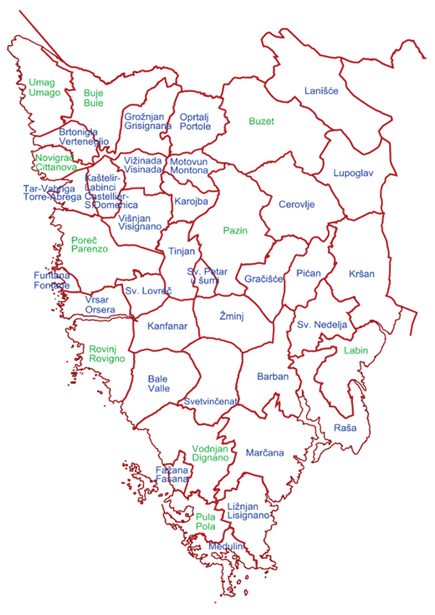
Picture 7: The Istria County

The County of Istria includes the biggest part of the Istrian peninsula in Croatia – 2.813 km², with the administrative centre in Pazin. Administratively, the Istrian County is divided into 31 municipalities and 10 cities. According to the census in 2011, the total number of inhabitants in the Istrian County is 208.055.

For the purpose of the SAA-2027, the main document used for the Istrian County is the Draft version of the County Development Strategy of the Istrian County until 2020. This Strategy defines the following vision and goals for the Istrian County:
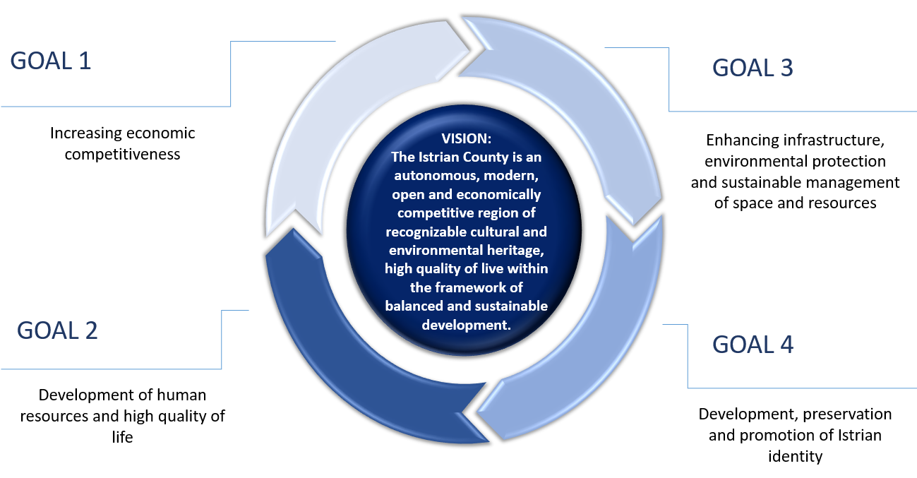
Picture 8: Vision and Strategic Goals of the Istrian County development

Goal 1 – Increasing economic competitiveness will be achieved by reducing and resolving development challenges that hinder further increase of the Istrian economy. This goal is strongly directed towards enhancement of research and development, usage of new technologies and innovation, improving business environment for the establishment of small and medium sized enterprises and by development of key economical branches, manufacture, tourism, agriculture and fishery. This is also reflected throughout the investment priorities defined for this goal:
- To strengthen research and development, the application of new technologies and innovations
- To enhance business environment for establishment and development of small and medium enterprises
- To develop key economical branches

Goal 2 – Development of human resources and high quality of life will be achieved by implementation of different interconnected measures directed towards increasing employability and mobility of the workforce, development of the educational system and its adjustments to the needs of the economy development, improvement of the health care and social care systems, development of sport and recreation, development of the civil society as well as the social entrepreneurship. As well, the achievement of this goal demands continuous investments in infrastructure. All this is also visible from the priorities defined in the strategy:
- To increase employment and workforce mobility
- To develop educational system and adjust it to the needs of the economic development
- To improve the health care and social care system and to promote health and social well-being
- To develop sport and recreation
- To develop civil society and social entrepreneurship

Goal 3 – Enhancing infrastructure, environmental protection and sustainable management of space and resources predicts measured and activities directed towards the improvement of the infrastructure systems in the field of transport, communications, energy and irrigation. Furthermore, it supports energy efficiency, promotion of renewable energy sources and co-generation, development of spatial planning and environment protection. This goal is directed towards the balanced development of the whole region (costal and continental) as well as the valorisation of environmental heritage, improved management of environment and risk management. This is also reflected in the priorities of the Goal 3:
- To increase energy efficiency, promote renewable energy sources and co-generation
- To enhance infrastructural systems
- To develop spatial planning and management as well as environmental protection
- To enhance efficient management of regional development
- To enforce the capacity for risk management and increase the level of readiness to respond to crisis events

Goal 4 – Development, preservation and promotion of Istrian identity is directed towards integrated and enhanced development of culture and cultural and creative industry, which includes construction and reconstruction of cultural infrastructure, supporting artistic production and increasing public interests for cultural heritage and modern artistic production, encouraging the usage of cultural and creative content for business purposes and the development of cultural entrepreneurship. Furthermore, this goal will be achieved through the investment into education, preservation and promotion of sustainable valorisation of cultural and natural heritage and throughout the development of the Istrian identity, networking off relevant institution and promotion of this Istrian identity. All these activities will be supported via the following investment priorities:
- To develop culture and cultural and creative industry
- To support preservation and development of Istrian identity components
- To present and promote Istrian identity

KOPRIVNICA - KRIŽEVCI COUNTY

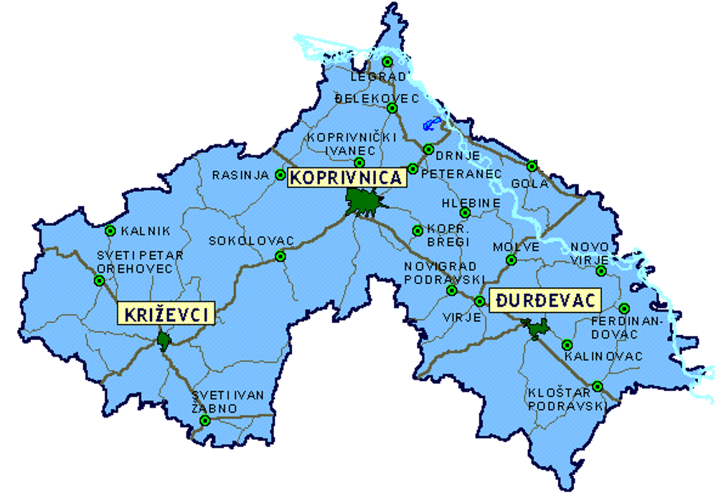
Picture 9: Koprivnica – Križevci County

The Koprivnica – Križevci County is located in the Northern part of Croatia, and it has and the county seat is in Koprivnica. The County covers the area of 1.748 km². According to the census from 2011, the County has 115.584 inhabitants. The county is divided into 3 cities and 22 municipalities.

In order to create the SAA-2027 the County Development Strategy for Koprivnica – Križevci County 2014 – 2020 has been used as a main development strategical document.

This document defines the development vision of the Koprivnica – Križevci County, as well as 4 goals that will contribute to the realisation of this vision:

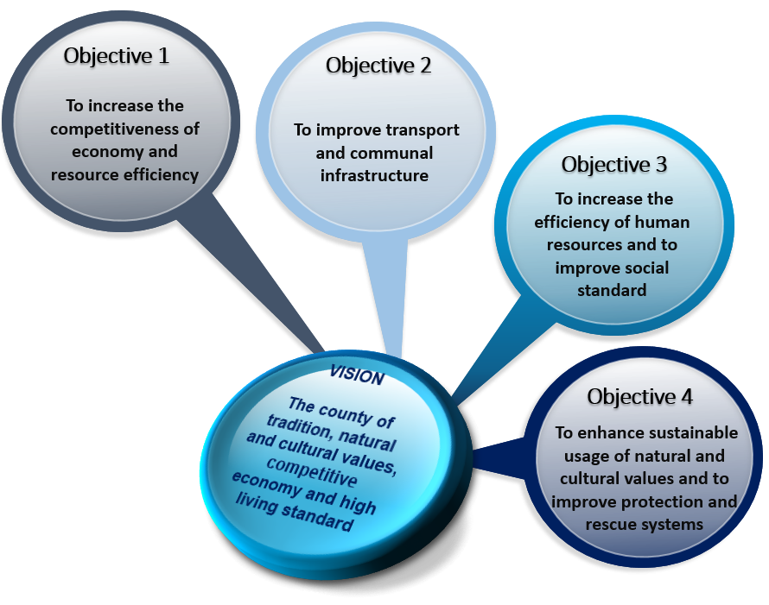
Picture 10: Development vision and goals of the Koprivnica – Križevci County

Goal 1 – To increase the competitiveness of economy and resource efficiency will be achieved with the increase of investments, mostly with the help of available and well-equipped entrepreneurial zones, support to the business networking, development of innovative and advanced e-business solutions, computerisation of public administration, developing the capacities of business support institutions, further development of business related infrastructure, education of entrepreneurs and spatial consolidation. In order to achieve this goal, the Koprivnica – Križevci County has defined the following priorities:
- Development of manufacturing industry activities
- Application of information and communication technologies
- Strengthening of entrepreneurship and entrepreneurial climate
- Rural development
- Tourism development
- Promotion of resource efficiency

Goal 2 – To improve transport and communal infrastructure will be realised through cadastre surveys, networking of institutional databases and update of spatial plans on regional and local level. Furthermore, this goal will support creation of obligatory and necessary project and technical documentation and modernisation or construction of transport and communal infrastructure. Furthermore, this goal will be achieved throughout the development of telecommunication infrastructure, sanitation of old or construction of new gas pipelines. The goal 2 will be achieved with the combination of activities implemented under following priorities:
- Development of strategical, spatial and project documentation and studies
- Development of transport infrastructure
- Development of communal infrastructure
- Development of infrastructure for sustainable waste management
- Development of communicational infrastructure
- Gasification
- Development of public lighting system

Goal 3 – To increase the efficiency of human resources and to improve social standards will be achieved by systematic strengthening of human resource capacities, implementation of lifelong learning programmes, and further development of the educational system and adjustment of educational programmes to the labour market needs. This is also reflected under the following investment priorities:
- Management of knowledge for efficient human resources
- Modernisation of the labour market on the county level
- Improvement of health and safety conditions of inhabitants
- Active population policy
- Development of social services
- Development of civil society

Goal 4 – To enhance sustainable usage of natural and cultural values and to improve protection and rescue systems will be achieved throughout the implementation of activities directed towards preservation of biological and landscape diversity, education about sustainable development and environmental protection, valorisation and preservation of cultural, historical and cultural values and improvement of protection and rescue systems. The achievement of this goal will be accomplished throughout the following priorities:
- Preservation of the generally useful nature functions
- Preservation of cultural heritage and support to cultural creativity
- Development of the protection and rescue system from elemental disasters.

KRAPINA - ZAGORJE COUNTY
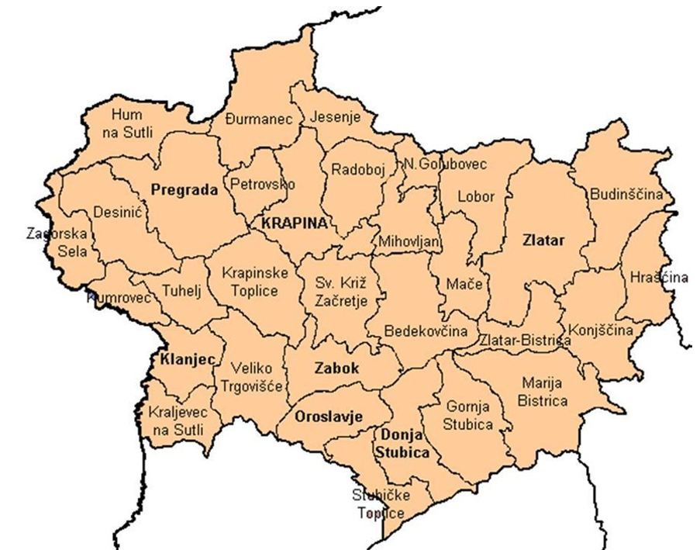

Picture 11: Krapina – Zagorje County

Krapina – Zagorje County is a county in Northern Croatia. It is one of smaller counties in Croatia and it covers the area of 1229 km². According to the national census in 2011, there are 132.892 inhabitants in total in the County.
For the purpose of this Strategy, a Development Strategy of Krapina – Zagorje County until 2020 has been used as a relevant strategic document. This document defines following development vision and goals of Krapina-Zagorje County for the period until 2020:
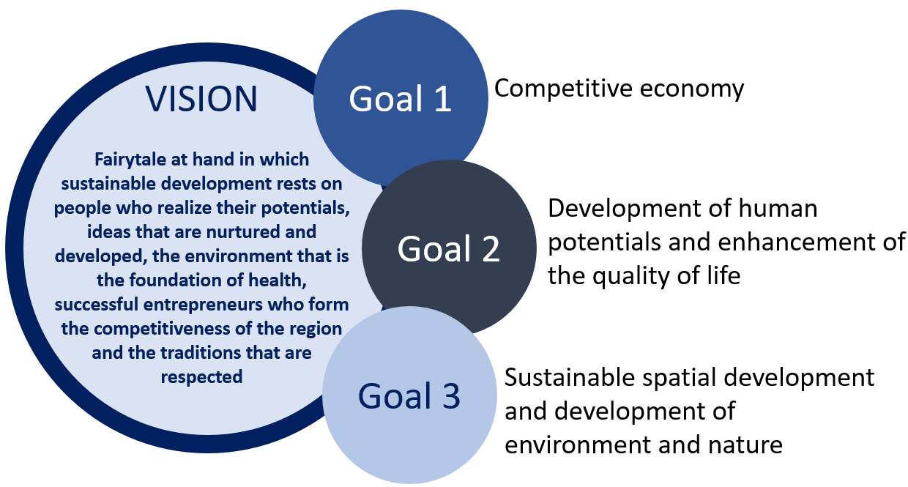
Picture 12: Development vision and goals of Krapina-Zagorje County
Goal 1 – Competitive economy will be achieved through systematic investment into the construction of necessary infrastructure that will enable development of entrepreneurship directed mostly towards manufacturing industry. It includes introduction of modern technologies and application of innovations in enterprises. Furthermore, secondary economy branches (agriculture and tourism) will be developed throughout putting into operation spas, castles, natural heritage, and modernisation of agricultural production and creation of recognisable regional products. The goal 1 will be achieved through following priorities:
- Development and enhancement of economical and entrepreneurial infrastructure
- Technological modernisation and strengthening the role of research and development
- Tourism development
- Development of agricultural production

Goal 2 – Development of human potentials and enhancement of the quality of life is supporting modernisation of educational system on all levels, renewal and equipping of schools which will result in entrepreneurial, competitive and flexible labour force which is in line with the labour market needs. Under the Goal 2 vocational education will be promoted, as well as the development of the health sector in line with the needs of inhabitants. In the field of social care, diversification of public and civil sector is supported, as well as promotion of inclusion. This goal is supported through the following priorities:
- Excellence of educational system
- Available and open health and social care
- Human resource development
- Increase of housing quality and population safety
- Strengthening the capacities of civil society organisations and civil initiatives

Goal 3 – Sustainable spatial development and development of environment and nature is directed towards systematic approach to the protection and preservation of cultural and natural heritage, especially for the tourism needs. This will be achieved via the valorisation of this heritage. Furthermore, this goal is also directed towards energy efficiency and the usage of renewable energy sources, development of transport infrastructure and improvement of general quality of life. In order to support Goal 3, following priorities have been identified:
- Preservation of biological and landscape diversity in function of development
- Environment preservation and sustainable development
- Development of communal and transport infrastructure and spatial organisation
- Sustainable management of natural and cultural heritage

MEDJIMURJE COUNTY
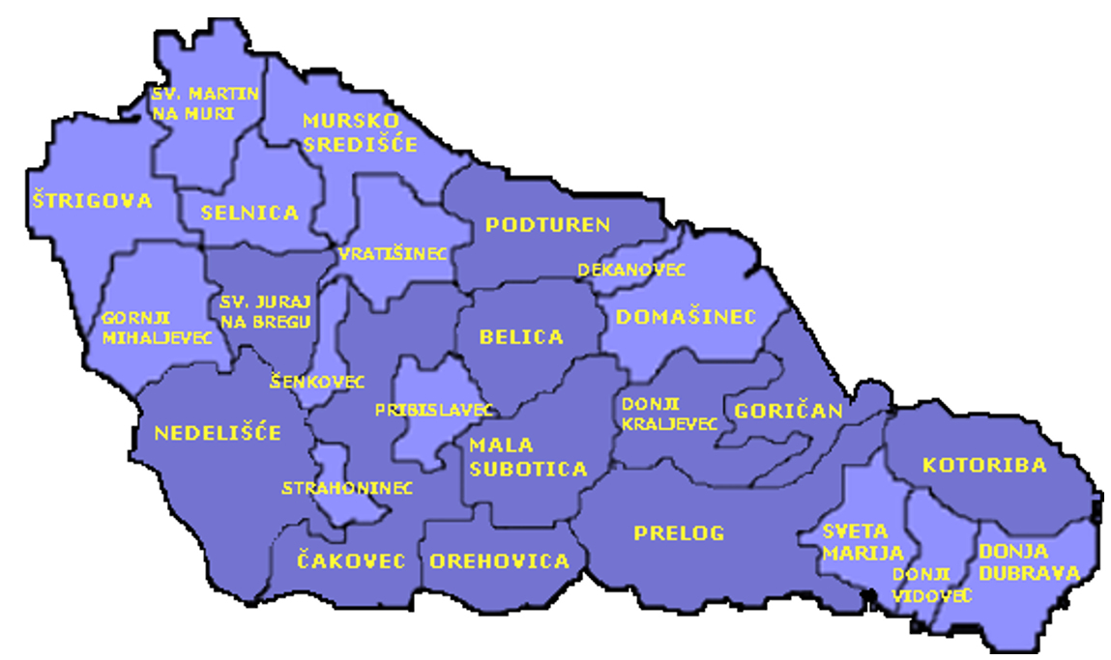
Picture 13: The Medimurje County

Medjimurje County is located in the northernmost part of Croatia. It is the smallest Croatian County covering the area of 729,58 km². Its administrative centre is the City of Cakovec. According to the census in 2011, there are 113.804 inhabitants living in the County. The Medjimurje County is divided into 3 cities and 22 municipalities.
The main strategical document that has been used for the purpose of this Strategy is the Development Strategy of the Medjimurje County until 2020.
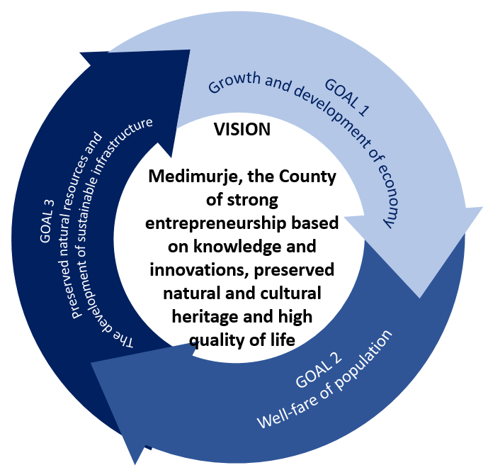
Picture 14: Development vision and goals of the Medjimurje County
Goal 1 – Growth and development of economy is directed towards ensuring greater availability of financial means for entrepreneurs, entrepreneurial education, investment in entrepreneurial zones and development of business support institutions. Furthermore, under this goal, investments in innovations, products and service development will be supported, as well as networking activities of entrepreneurs and joint appearance on the market. Furthermore, this goal supports the development of tourism and agricultural sector through education, land consolidation and enhancement of manufacturing and storage capacities. In the field of tourism, this goal will contribute to the establishment of tourism destination of management system, branding of the region and development of integrated tourism products. All this will be achieved through measures and actions implemented in the frame of following priorities:
- Creation of pre-conditions for strengthening of the competitiveness of economy in global
- Supporting innovation and the development of products and services with higher additional value
- Organisation on market and the promotion of economy
- Increasing the competitiveness of agricultural sector and introduction of the Medjimurje quality system
- Development and promotion of tourism offer for positioning Medjimurje as a tourism destination

Goal 2 – Well-fare of population - This goal will be achieved throughout continuous investment into education, and lifelong learning, especially the development of new and adjustment of existing programmes for pre-qualification competency development. This goal is also directed towards improvement of educational infrastructure and additional work with students with special needs as well as Roma students. Young unemployed people will have the opportunity to participate in additional vocational education and training. In the health sector, better availability of primary health care will be supported, as well as providing larger number of services by general practice provider, in order to lower the number of people using hospital services and to lower the pressure on hospitals. Additional education of health care service providers, development of palliative care and adequate psychological care (especially for children), development of health infrastructure and preventive actions, deinstitutionalisations are also included in this goal. Furthermore, promotion of active participation of civil society organisation in all segments is also a very important tool to ensure the achievement of the Goal 2, as well as improvement of conditions in the cultural sector (through the creation of the Culture Development Strategy, revitalisation of cultural heritage, promotion and the development of modern culture). Inside this goal, activities and measures are divided into following priorities:
- Promotion of employment, education and lifelong learning
- Enhancement of populations’ health and the quality of health services
- Strengthening of social inclusion of groups in vulnerable position
- Strengthening the role of civil society
- Preservation, development and promotion of all forms of culture
- Improving the availability of services for the population

Goal 3 – Preserved natural resources and the development of sustainable infrastructure is directed towards strengthening of institutional and human capacities in the field of nature and environmental protection, awareness rising and education of population on the importance of environmental protection (including responsible usage of chemical resources in agriculture, importance of using available communal facilities). Furthermore, investments in water supply, wastewater collection and treatment, responsible waste management and education of population about responsible usage of resources, investments into broadband infrastructure and the development of complementary services, energy efficiency and promotion and support to usage renewable energy sources are all interconnected measures inside this goal. In accordance with this, the Goal 3 is divided into the following priorities:
- Protection of nature and environment
- Systematic development of transport and telecommunication infrastructure
- Achieving higher energy efficiency
- Preventive actions and mitigation of impact of natural and elementary disasters

SLOVENIA
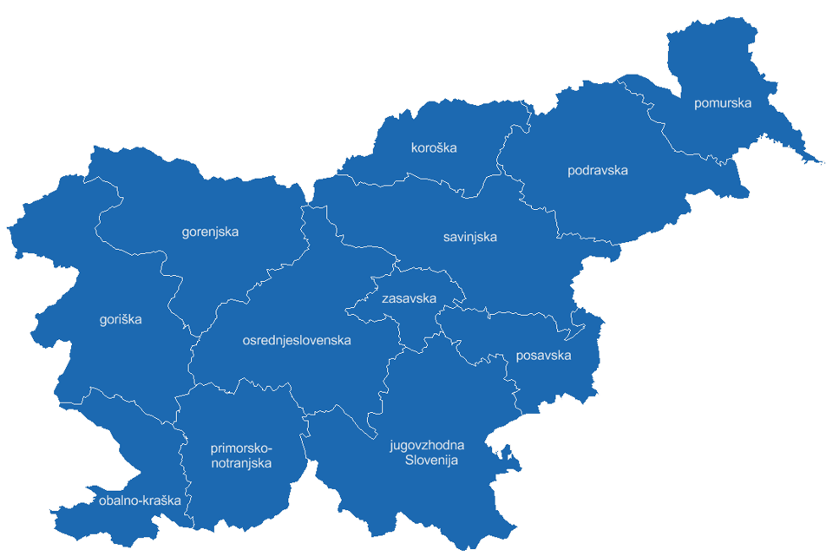
Picture 15: NUTS 3 Statistical regions in Slovenia

The territory of the whole Slovenia is included in the AAA, thanks to the fact that the Association of Municipalities and towns in Slovenia is an active member in the Aliance. The Association covers the territory of the whole Slovenia, i.e. 20.273 km² and it includes 212 municipalities, of which are 11 urban municipalities. According to the prediction of number of inhabitants for 2015., there are 2.066.880 inhabitants in total living in Slovenia.
Since Slovenia is in Alps – Adriatic Association represented as a whole, the relevant development document used for the needs of this Strategy is The Development Strategy of Slovenia 2030.
This Strategy is based on following vision and development goals:
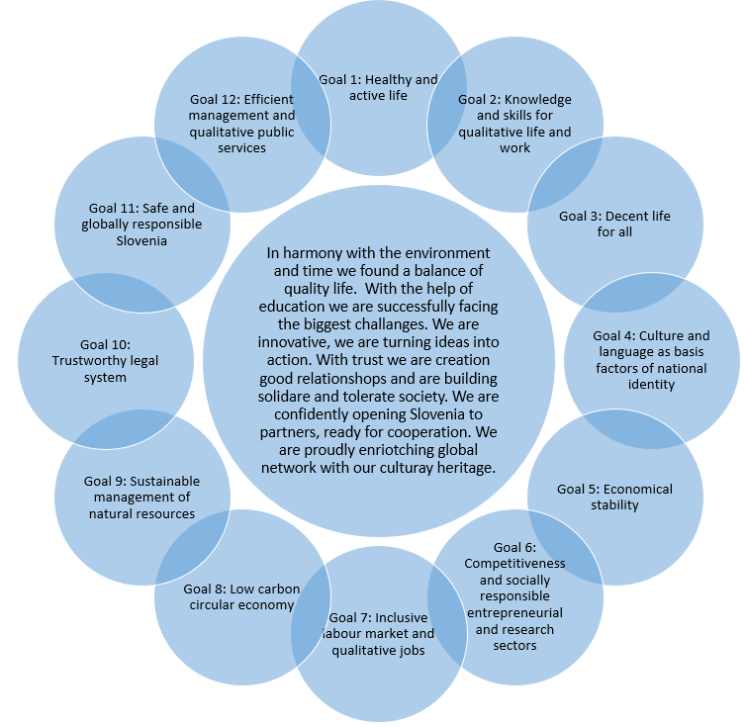
Picture 16: Development vision and goals of Slovenia

Goal 1 – Healthy and active life will support actions directed towards adjustment of civil sub-systems to changed age structure of population, especially in the field of labour market, social protection, education, health, culture, spatial planning, communication and transport systems. As well, this goal will be directed towards ensuring qualitative and on time health services and the development of supporting environment for all social groups and towards promotion of higher mobility of inhabitants. In order to achieve this goal, the activities linked with awareness rising and education about the importance of healthy life style, physical activity and healthy nutrition, managing risk behaviour, care for mental health and diseases prevention will be implemented. Additionally, this goal will be achieved through promotion of activities directed towards reducing environmental pollution, changing consumer patterns, management of social differences, intergenerational knowledge transfer, ensuring equal opportunities and gender equality, social inclusion and work and private life balance.
Goal 2 – Knowledge and skills for qualitative life and work – will be achieved through supporting activities directed towards supporting lifelong learning as a value that strengthens creativity, innovations, critical thinking, responsibility and entrepreneurship, development of knowledge and skills in order to improve reading, mathematical, digital and financial literacy, encouraging global education and ICT usage for educational purposes. Furthermore, the concepts of sustainable development, active citizenship and ethics will be incorporated as one of the basis of education and training. As one of the priorities of this goal, the inclusion of citizens with low educational levels and other disadvantaged groups into the educational system is defined as one of the main measures. Support to the scientific development and research in line with the market needs will also be promoted in the frame of this goal.
Goal 3 – Decent life for all will be achieved throughout ensuring appropriate levels of income for decent live and for lowering the risks for social exclusion and poverty. Furthermore, this goal will support throughout ensuring security and protection of families and children, creation of encouraging environment for upbringing of children, improving the quality of the living environment, ensuring the availability of adequate living facilities for all generations (including transport connections), ensuring sustainable systems of social protection, promoting cooperation, solidarity, social innovations and volunteering, removing all forms of discrimination, family violence, hate speech and racially motivated violence.
Goal 4 – Culture and language as basis factors for national identity is directed towards preservation of Slovenian language, culture, and cultural and natural heritage, strengthening of national identity, preservation of cultural diversity, encouraging the management of cultural heritage based on efficient management. As well, this goal is directed towards digitalisation in order to enable preservation, presentation and availability of cultural heritage, applying the principles of inclusion into management of cultural values, promotion cooperation between economic and cultural sector, promotion of cultural and creative industry and promotion of Slovenian culture and sport on international level.
Goal 5 – Economic stability is directed towards ensuring sustainable and inclusive economic development, encouraging countercyclical economic policies, strengthening of functional regions as development and economic units, supporting development based on the exploitation of development opportunities and traffic connectivity. Naturally, this goal also includes the development of sustainable solutions for balanced private and public sector and ensuring the competitiveness of the financial market.
Goal 6 – Competitive and socially responsible entrepreneurial and research sectors includes further development of scientific and research sector and the transfer of the research solutions into the economy in order to develop high competitive economy. Encouraging internationalisation of enterprises, development of encouraging and predictable supporting environment, standardisation systems, accreditations and the development of enterprises based on high technological solutions are also activities supported by this goal. As well, in the frame of this goal, the development of high digitalised environment, based on new research and technological ideas and globally competitive systems, encouraging the creative solutions and connections to science and art, environmental and social corporate responsibility will be supported.
Goal 7 – Inclusive labour market and qualitative jobs will support the inclusion of the concept of sustainable working life into the entrepreneurial policies, creation of qualitative job that are generating higher added values, are environmentally responsible and are ensuring the conditions for adequate salary and qualitative working environment. Throughout this goal a higher inclusion of disadvantaged groups will be encouraged as well as the adjustment of jobs and organisations to demographic changes and introduction of ICT into the working environment. Furthermore, this goal will be directed towards encouraging of activities of employers linked with the strengthening of mental and physical health of employers as well as easier harmonisation of working and private life.
Goal 8 – Low carbon circular economy will be based on the interruption of connection between economic growth and increased usage of resources and green gas emission, mostly through education and connection of different stakeholders into circular economy. As well, this goal will be directed towards supporting innovations, ICT usage for the development of new business models and products in order to ensure efficient usage of resources and energy. In the frame of this goal, actions directed towards increased usage of renewable energy sources and energy efficiency and matching interests on all horizontal areas (food – water – energy – eco-systems) will be supported, as well as support to the low energy transportation systems and to the sustainable mobility through the introduction of new mobility concepts and increased ratio of public transportation.
Goal 9 – Sustainable management of natural resources will support introduction of management of natural resources based on the eco-systems, efficient water management, ensuring sustainable development of forests as an eco-system, based on its ecological, economic and social functions, prevention of cross-border pollution of all environmental factors, ensuring high degree of biological diversity and quality of natural values, prevention of further soil degradation and rehabilitation of degraded soils. Activities supported throughout this goal also include sustainable protection and quality preservation of agricultural lands, supporting agricultural practices in order to ensure increased supply of locally produced food, ensuring quality living environment based on responsible and efficient spatial planning and ensuring quality management systems on all levels.
Goal 10 – Trustworthy legal system is directed towards protection of all human rights and freedoms, discouraging discriminations and ensuring equal opportunities on national, regional and local levels, enabling uniform law practice with clear procedural and substantive legislation, preservation of judiciary independence and efficient and transparent implementation of judiciary procedures. As well, this goal will support the culture of out-of-court settlement of disputes, prevention, early discovery and sanctioning of corruption and implementation of prevention activities in order to lower the risks for emergence of disputes.
Goal 11 – Safe and globally responsible Slovenia should be achieved through the implementation of activities directed towards terrorism protection and prevention of other national threats, ensuring high level of security of people and unhindered functioning of critical infrastructure, establishment of comprehensive and efficient systems of cyber and IT security and response to the cyber threats. Actions under this goal will also support readiness and response activities for comprehensive management of natural and other accidents, ensuring the safety of internal and external borders of EU and developing comprehensive solutions for efficient management of global migration flows through the cooperation with origin, transit and targeted countries. This goal will also support the assurance of capabilities for national defences and strengthening external political participation.
Goal 12 – Efficient management and qualitative public services will be achieved via activities directed towards development of high cooperation culture and enhancement of trust levels between citizens, employees and institutions as well as the development of new forms of connections. Furthermore, this goal will strengthen the trust in institutions, primarily through the implementation of “equality for everyone” rule, zero corruption tolerance, transparent information and high quality regulations. As well, the activities under the umbrella of this goal will support the enforcement of the standards of participative democracy, support to the cooperation and taking responsibility as a partner in social dialogue, development of available and efficient public services and at the same time the exploiting the possibilities of digitalisation, encouragement of intergeneration knowledge and skill transfer and the support of innovative models of management, leadership and policy creation.

STYRIA
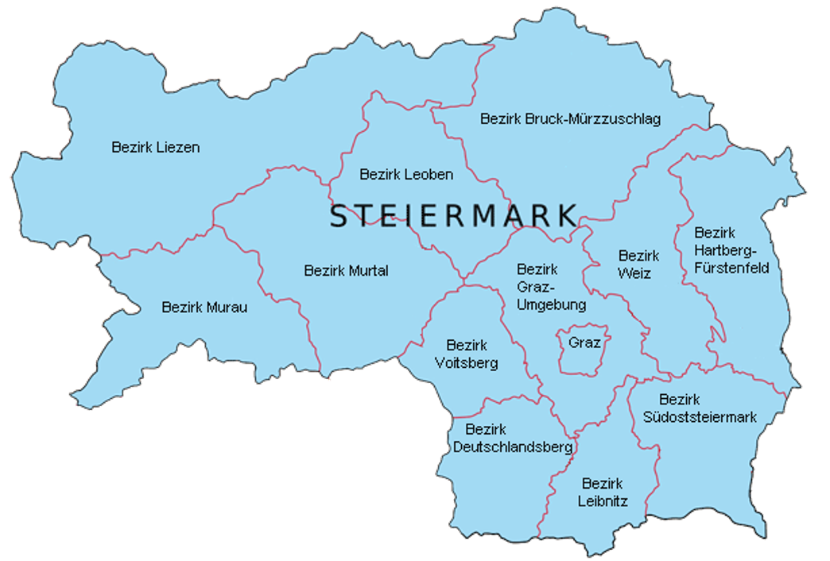
Picture 17: The Styria State

The Styria state is the second largest Austrian federate state, covering 16.401 km² with Graz as an administrative capital of the state. Based on the data from 2017, there are 1.237.296 inhabitants living in Styria. It covers 252 municipalities and 35 cities in total.
Styria is made of 7 districts and each of these districts has its own strategic development document. For the purpose of this Strategy all these 7 strategic documents have been analysed. Below are presented short graphical reviews of goals and visions of each of these districts.

Liezen Region
The Liezen region based its development on 6 interconnected strategic goals:
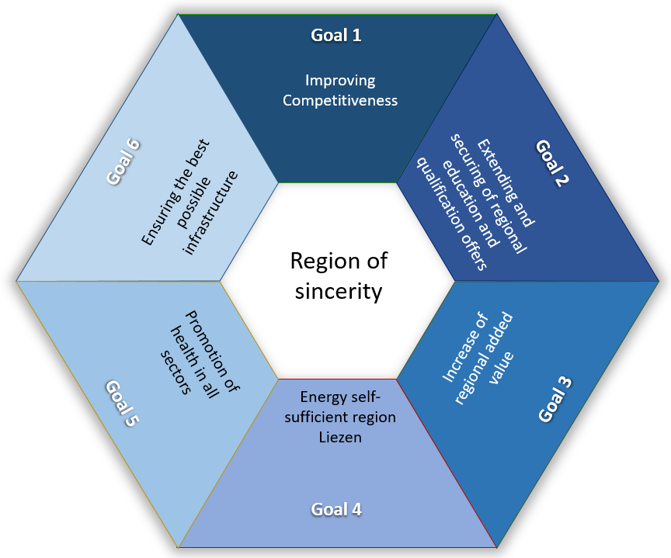
Picture 18: Development goals of the Liezen Region

Obersteiermark Ost Region
The Obersteiermark Ost Region has defined 4 strategic development goals which should contribute to the achievement of the vision:
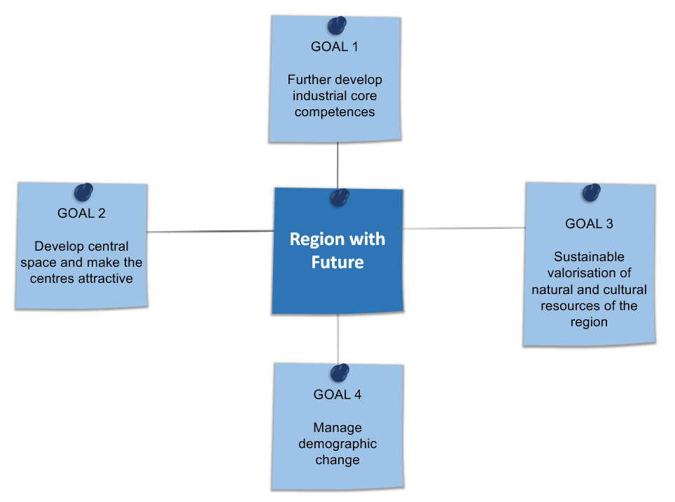
Picture 19: Development goals of the Obersteiermark Ost Region

Obersteiermark West Region

The Obersteiermark West Region has defined its development strategy throughout a vision and 6 development themes:
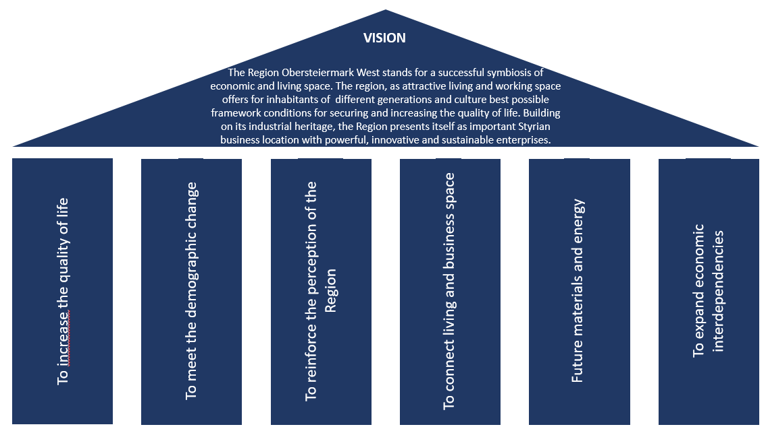
Picture 20: Development themes of the Obersteiermark West Region

Oststeiermark Region
The development strategy of the Oststeiermark region contain five interconnected strategy themes, defined based on the special characteristics of the region:
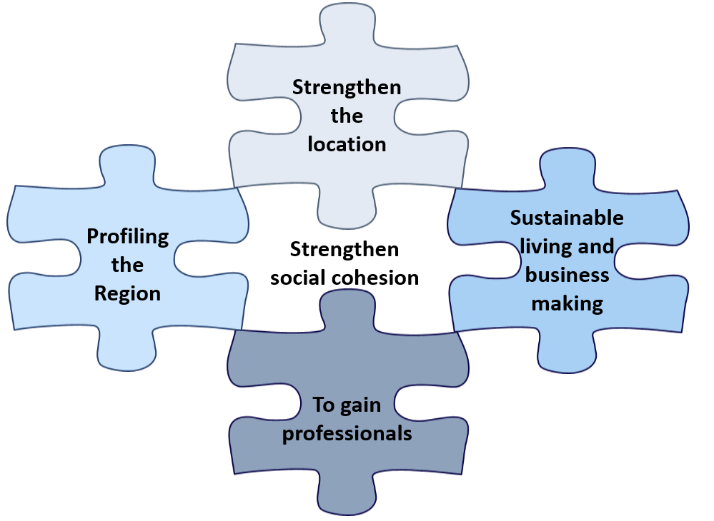
Picture 21: Strategy themes of the Oststeiermark Region

Südoststeiermark Region
Südoststeiermark Region has defined the following vision and 10 action fields in order to secure human, environmental and economic sustainability of the region:
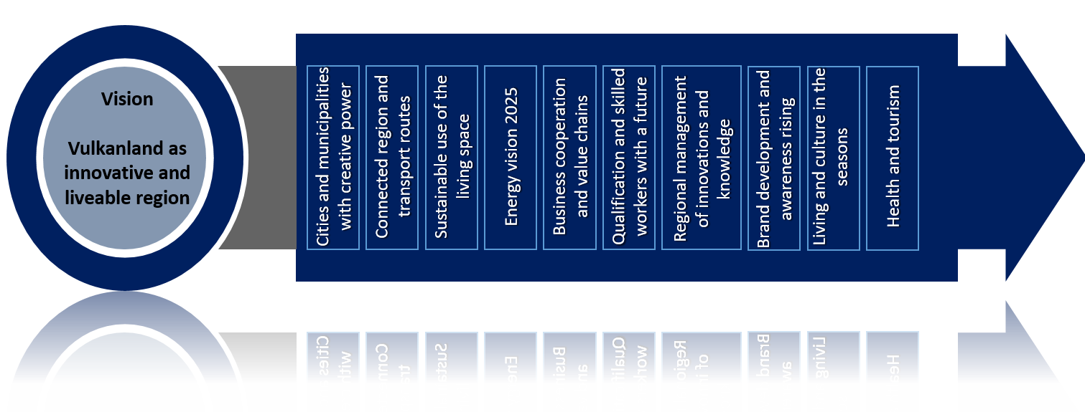
Picture 22: Development action fields of the Südoststeiermark Region

Südweststeiermark Region
The Südweststeiermark Region has defined 4 strategic goals in order to achieve the vision of the region:
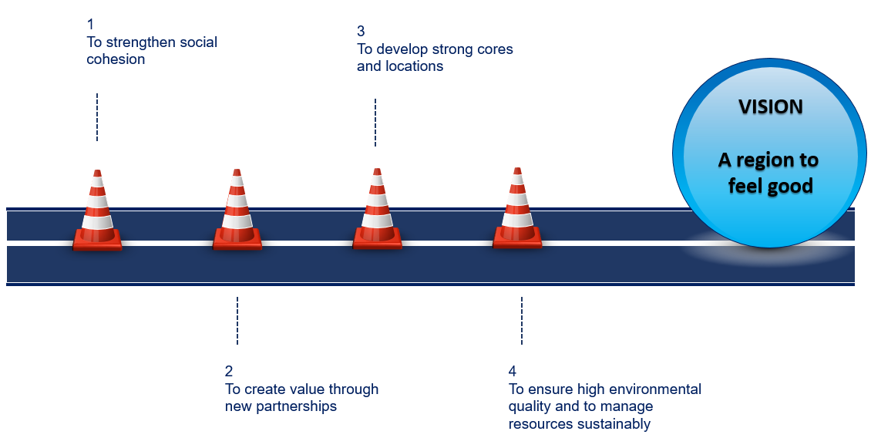
Picture 23: Strategic goals of the Südweststeiermark Region

Region Steirischer Zentralraum
For the Region Steirischer Zentralraum 4 general objectives have been identified in order to support the achievement of the vision:

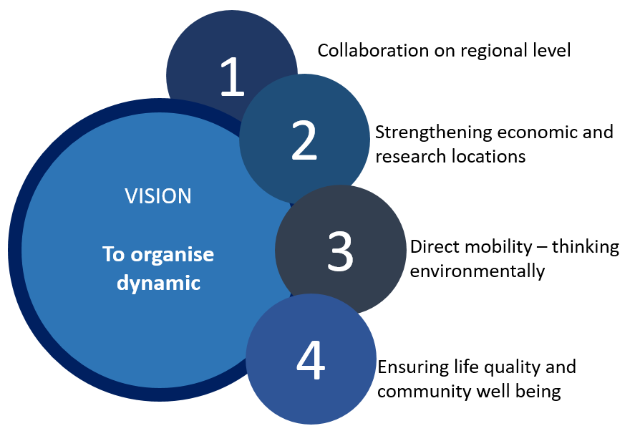
Picture 24: General development objectives of the Steirischer Zentralraum Region

VARAŽDIN COUNTY

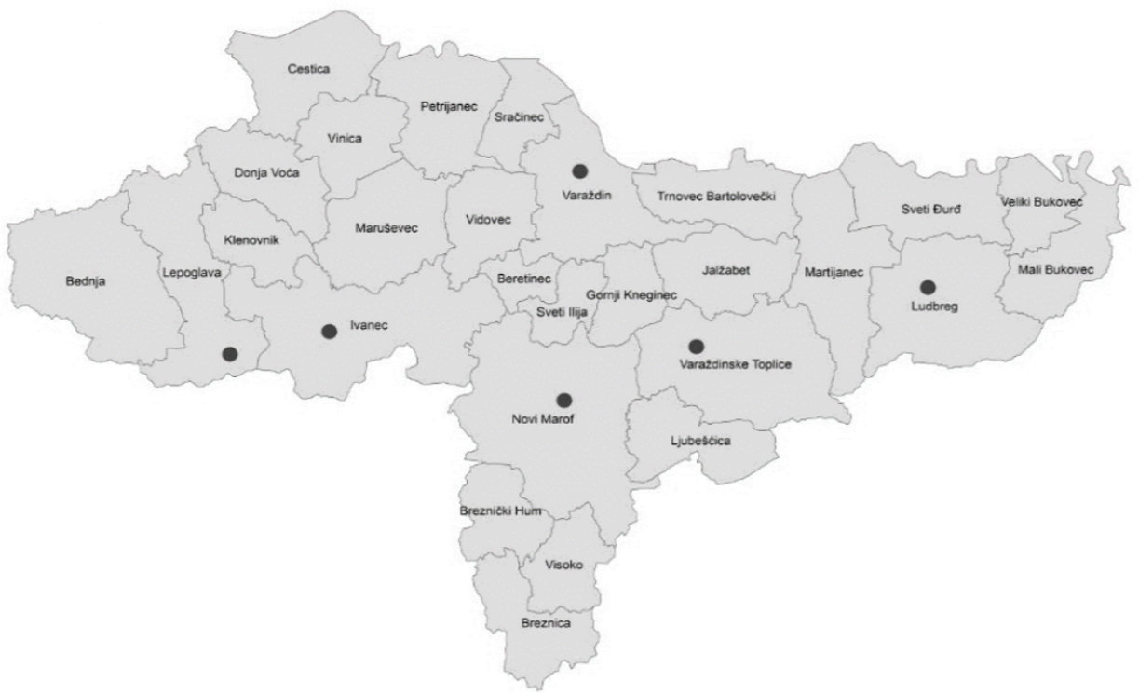
Picture 25: Varaždin County
Varaždin County is placed in the northern part of Croatia and it is covering 1.262 km². The administrative centre of the County is the City of Varaždin. Varaždin County is made of 6 cities and 22 municipalities. According to the census from 2011, it has the population of 175.951.
For the purpose of this Strategy, the Draft version of the County Development Strategy of the Varaždin County until 2020 has been used. This strategy defines the vision and the development goals of the Varaždin County as follows:
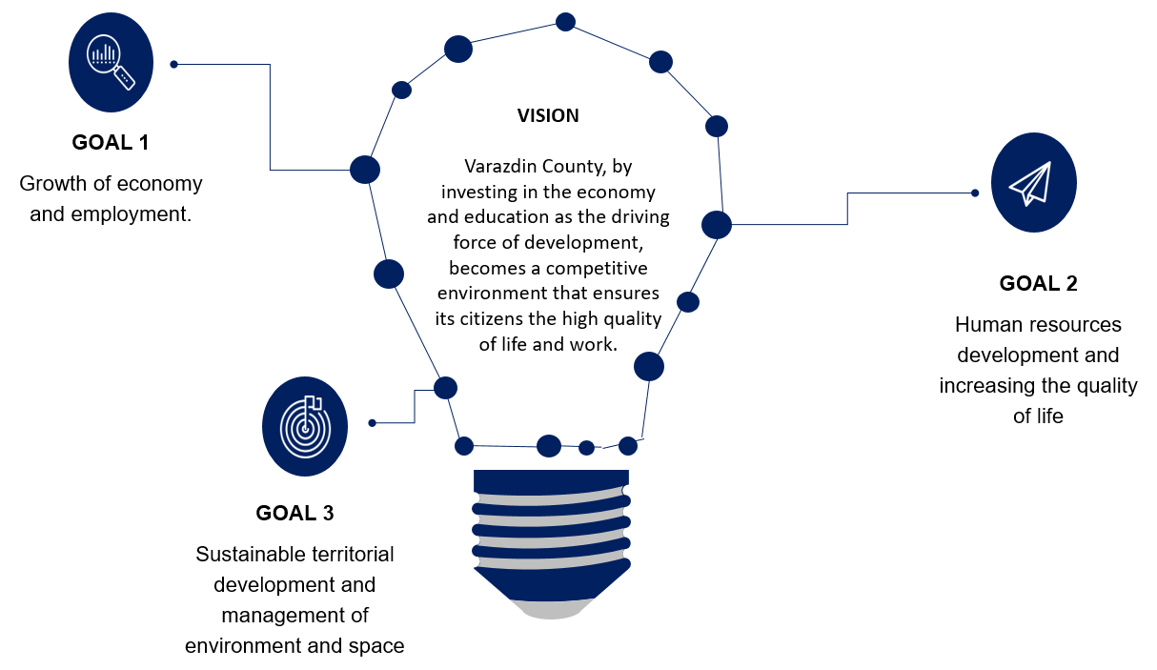
Picture 26: Vision and development goals of Varaždin County

Goal 1 – Growth of economy and employment will support activities directed towards the improvement of business environment, development of knowledge and innovation based economy, attracting investments, creation of preconditions for better understanding of entrepreneurship, especially among youth and education. Furthermore, activities in the frame of this goal are promoting the development of business support sector through establishment and/or further development of business incubators, business zones and centres of competences. In the agricultural sector, this goal is directed towards further development of agriculture, supporting investments in farms, cooperation, ecological agriculture, traditional production and services and education of farmers. In the tourism sector, activities will cover creation of new tourism products and making them recognisable on international level.
Goal 2- Human resources development and increasing the quality of life is based on the investment into human resources through education, social integration, improvement of the health care and social care systems, promotion of active aging, integration of disadvantaged groups into the community, improvement of civil cohesion of population through encouragement of volunteering, development of civil content in local communities and improvement of the public institution services.
Goal 3 – Sustainable territorial development and management of environment and space includes implementation of activities related to the improvement of transport infrastructure and all segments of traffic security, modernisation and/or construction of communal infrastructure, development of broadband infrastructure, improvement of protection and rescue systems as well as implementation of activities linked with environment protection, energy efficiency and renewable energy sources. Furthermore, protection and valorisation of natural and cultural heritage, spatial planning and management and efficient management of nature will also be supported throughout this goal.

VAS COUNTY

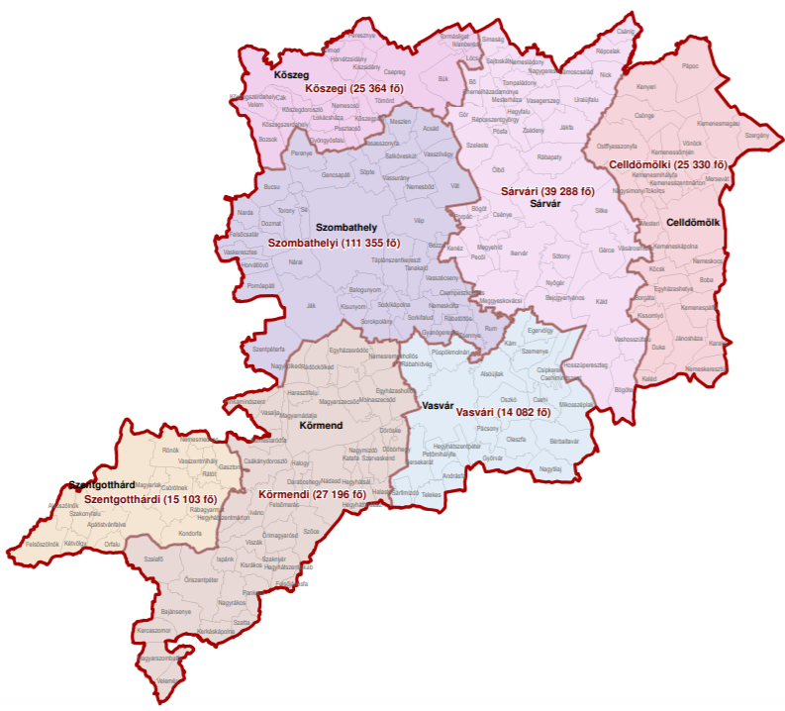
Picture 27: Vas County

Vas County is placed in the Western Hungary, with the administrative centre in Szombathely. Vas County covers the region of 3.336,14 km². The Vas County is divided into 7 districts that include 216 municipalities and 13 cities. According to the data from 2016, there are total 253.689 inhabitants in Vas County.
The strategy used for the purpose of this Strategy representing Vas County is Integrated Regional Programme of Vas County 2014 – 2020. This strategic document defines 4 development goals of Vas County:
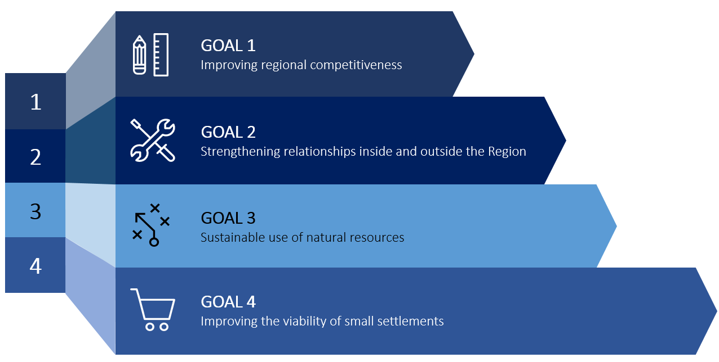
Picture 28: Development goals of the Vas County

Goal 1 – Improving regional competitiveness includes measures linked with the development of the local economic infrastructure, employment co-operations for expansion employment and local community programmes are supported.
Goal 2 – Strengthening relationships inside and outside the region supports the activities directed towards transport development in order to boost economic development and to encourage labour mobility.
Goal 3 – Sustainable use of natural resources is directed towards the development of socially and environmentally sustainable tourism, increasing energy efficiency and the proportion of renewable energy consumption. As well, this goal supports development of settlements in order to achieve economic revitalisation and retain population, development of sustainable urban transport, rehabilitation of declined urban areas and complex programmes at local level in order to strengthen social cooperation.
Goal 4 – Improving the viability of small settlements supports measures directed towards assistance to employment and improvement of the quality of life through the development of family-friendly institutions and public services. Under this goal development of the infrastructure for basic health care will be supported as well as the expansion and improvement of infrastructure needed for basic social services.

PRIMORJE – GORSKI KOTAR COUNTY
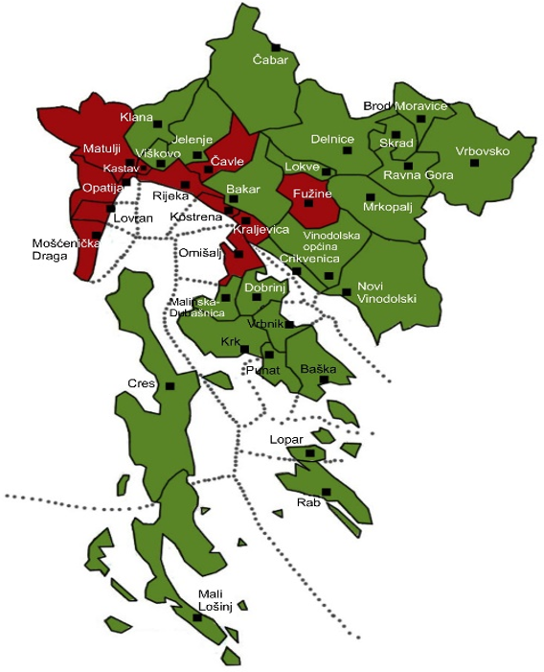
Picture 29: Primorje – Gorski Kotar County

Primorje – Gorski Kotar County is placed in the western Croatia. Geographically, it includes the Bay of Kvarner, the surrounding Northern Croatian Littoral and the mountainous region of Gorski Kotar. Administrative centre of the County is the City of Rijeka. The county covers the area of 3.588 km². According to the 2011 census, there are 296.195 inhabitants in the Primorje – Gorski Kotar County, which live in 14 cities and 22 municipalities.
For the purpose of this Strategy, the Development Strategy of the Primorje – Gorski Kotar County 2016 – 2020 has been used as a central strategic document. This document defines the development vision and three strategic goals as follows:
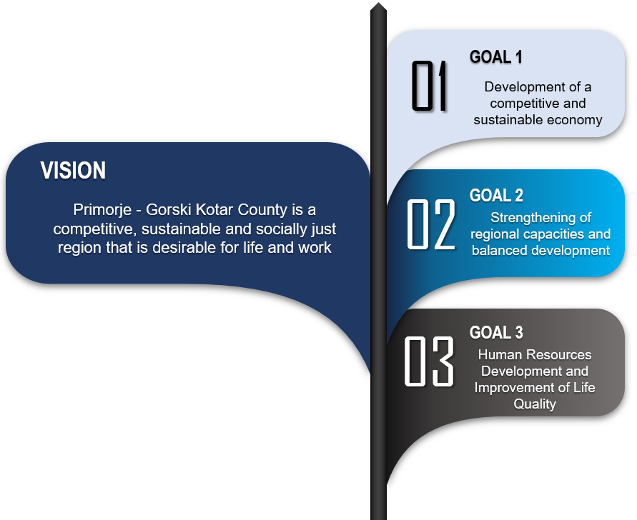
Picture 30: Development vision and goals of the Primorje – Gorski Kotar County

Goal 1 – Development of a competitive and sustainable economy will support activities linked with the creation of the supporting entrepreneurial environment through the development of supporting entrepreneurial infrastructure, supporting the competitiveness of small and medium sized enterprises, cauterisation and corporate social responsibility. This goal also supports attracting domestic and foreign investments via creation of positive investment climate, providing support to export activities and the promotion of the economy. Goal 1 is also directed towards the development of a knowledge-based and innovation-based economy by enabling the conditions for the development and implementation of new technologies and innovations into economy, strengthening the capacities of research and innovation infrastructure, supporting the development of cultural and creative industries as well as health industries. The development of the green economy will be achieved through the development of agriculture, forestry, fishery and hunting, supporting the economy based on low greenhouse gases emission in all sectors and the usage of the renewable energy sources and energy efficiency. The development of key economic activities will be supported by the development of transport, energy, tourism and industry, as well as through the support to the usage of the ICT.
Goal 2 – Strengthening of regional capacities and balanced development will support balanced development of social and economic services and content, development of urban and rural areas, providing a high quality transport system as well as communal infrastructure. Sustainable management of environment and cultural and natural heritage will be achieved through integrated management of see and costal area, protection and management of all environmental components, improvement of integrated waste management system and sustainable management of cultural and historical heritage. Furthermore, this goal supports strengthening of capacities for the cooperation with civil society through the promotion of national minorities, multiculturalism and improvement of the prevention, protection and rescue system.
Goal 3 – Human resource Development and improvement of life quality includes priorities linked with the creation of conditions for the labour market development and supporting the mobility of the workforce and the improvement of the educational system, including the harmonisation of this system with the labour market needs. This goal also support investments directly linked with the improvement of health and social welfare in the region, enhancing social security and promotion of social inclusion. Goal 3 is also directly linked with the improvement of quality and availability of different cultural and sport contents in the region.

JOINT AREAS OF INTEREST

When compared, it is visible that each member has similar, but also different characteristics. This is especially visible when comparing available population data as well as the main economic factors:
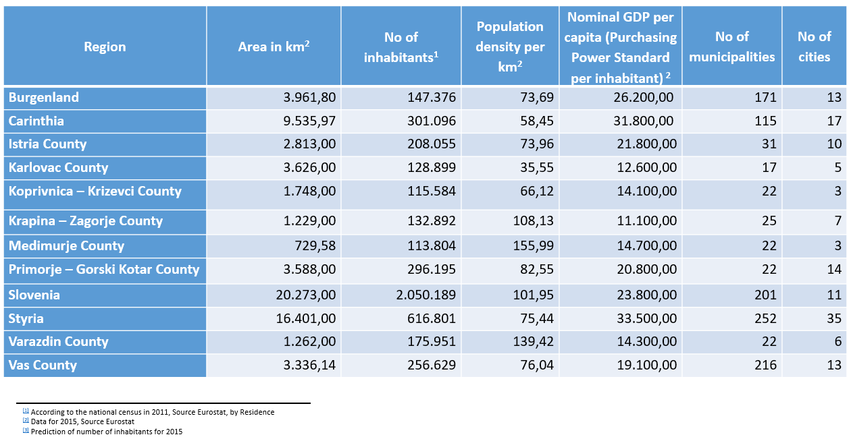
Picture 31: Comparison of members
It is visible that the Alps – Adriatic members differ strongly in the size as well as in the population numbers. Although the data about the number of inhabitants are not from the same year, the trends in the past years have not shown the significant change in trends that could have serious impact on the comparison analysis.
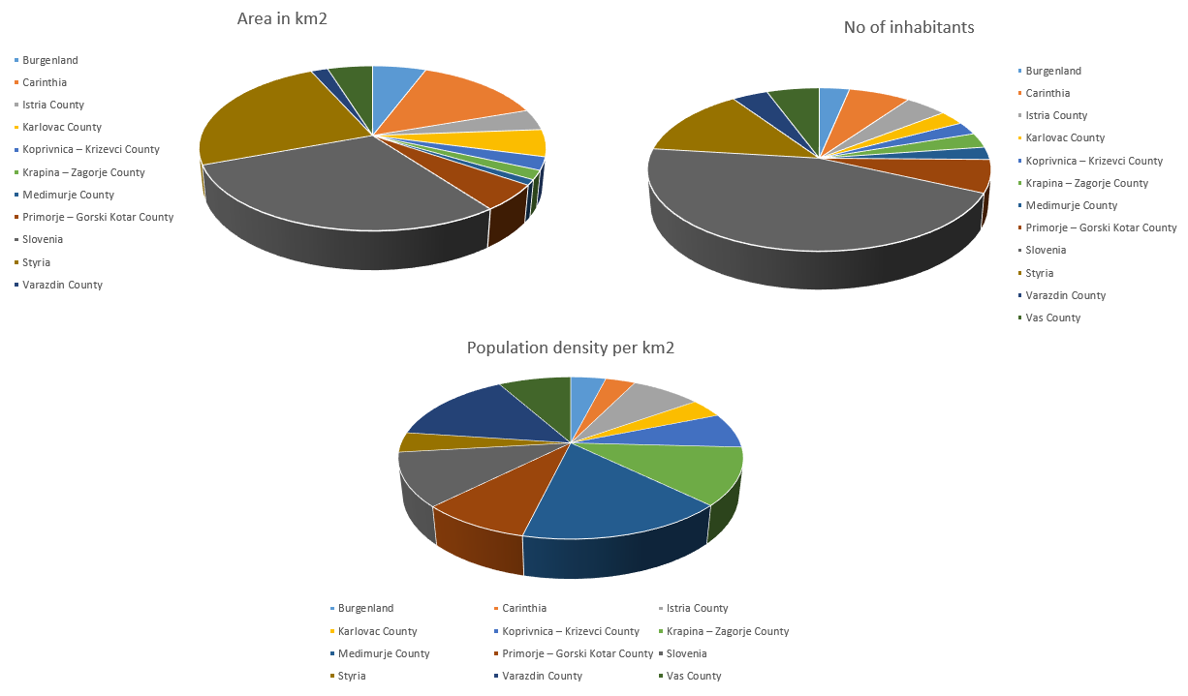
Picture 32: Comparison of the population in the Alps – Adriatic region
The comparison of each member, when it comes to the population shows that the most densely populated is Medimurje county, which is also the smallest member. Furthermore, the average population density of the whole Alps – Adriatic region is 87,27 inhabitants per km², which places the area in EU terms as middle densely populated area.
When it comes to the administrative units (municipalities and cities), each member has this governed according to its national regulations. But, all in all, the general conclusion is that members differ significantly in the number of municipalities, while there is not a lager difference when it comes to the number of cities. When the number of administrative units is compared to the size of each member, Karlovac County has the largest average size of the administrative unit, while Vas County has the smallest:
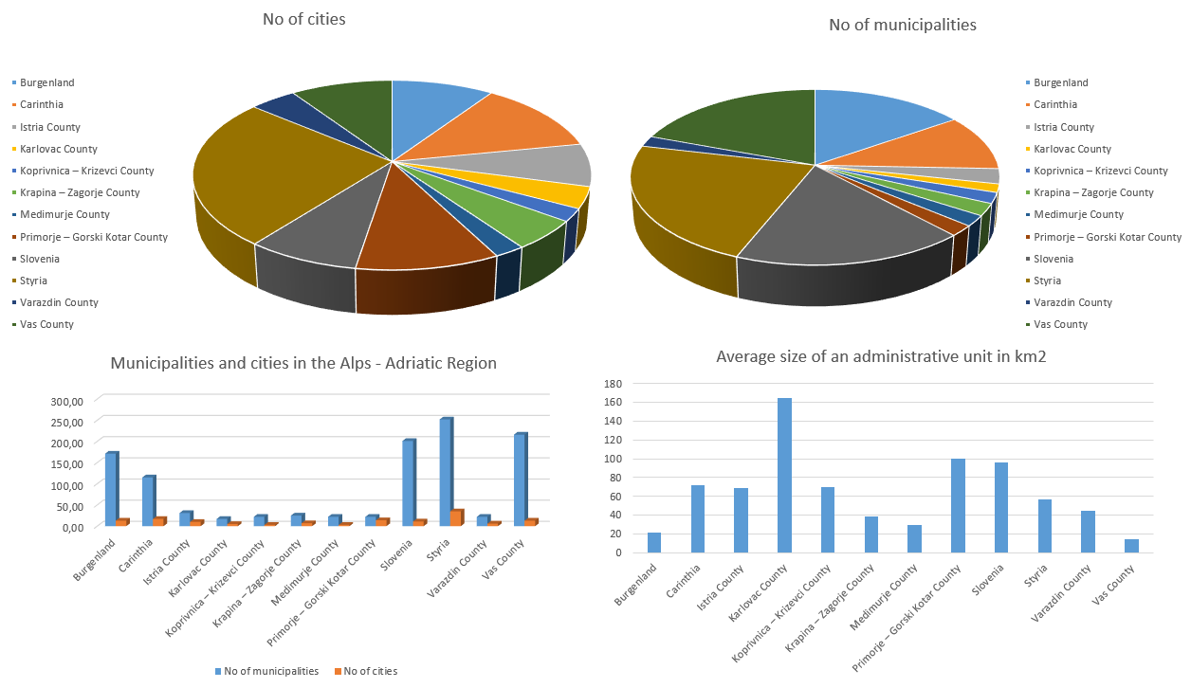
Picture 33: Administrative comparison of the members

The detailed analysis of the strategical development documents of members has shown that defined development needs and opportunities depend highly on the geographical characteristics, internal administration of member, available resources and the characteristics of population (number of inhabitants, education level, mobility etc.). Therefore, each member has identified the needs and opportunities that are reflecting its own specific conditions and the desired development direction.
As well, the detailed analysis has shown that each of the members has predicted a specific set of development measures, actions and projects to overcome the challenges identified for each member. This set of measures, actions and projects encompass so called soft activities mostly directed towards education, awareness rising and behaviour changing of target groups, complemented with the infrastructural activities aimed at supporting the results of soft activities.
Except the similar approach to the specific challenges of each member, the detailed analysis has also shown that all members have identified similar priority areas of action when it comes to the implementation of defined sets of activities. Although some activities are very specific for each member, based on the analysis of main development priorities, goals and mission of members, it is visible that the development efforts shared by all members are directed towards:
- Protection and valorisation of natural and cultural heritage
- Employment and the development of entrepreneurship
- Energy efficiency and renewable energy sources
- Environmental protection
- Healthcare and social care development
- Improving educational conditions and modernisation of education systems
- Civil society development
Moreover, there are two joint areas of intervention that could be considered as horizontal areas in the whole region. One of it is research, development and innovations since it is mentioned in almost all other areas. The second one is linked with the public administration, since all members are recognising, in one way or another, the importance of more efficient and “user friendly” public administration as a key factor to boost the development of each member.
Although these are results based on the analysis of the members that submitted the questionnaires, it is to expect that the situation is similar in all members. Therefore, from now on, this document will be based on the assumption that the situation is similar in the whole Alps – Adriatic region and that these 7 identified areas of intervention are common for all Alps – Adriatic partnership region.

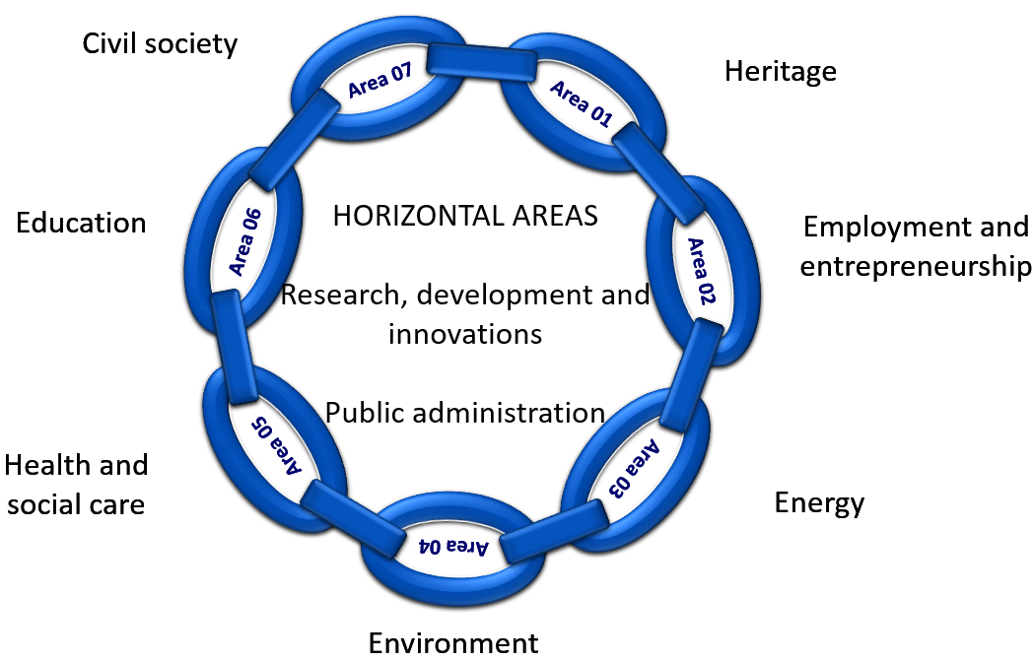
Picture 34: Common areas of intervention

VISION AND STRETEGIC OBJECTIVES

VISION
Based on the previous findings and the development visions of members, a shared vision for the SAA-2027 emerged:
A region of strong, integrated communities where diversity is considered a strength rather than weakness. A region tailored to the needs of population in harmony with the healthy environment.

This vision builds on the fact that the Alps – Adriatic region is characterized by the members that are diverse in tradition, language, geography, administration, natural resources and population characteristics. In order to succeed and to achieve joint development, this diversity needs to be accepted as the key success factor of the SAA-2027. In order to ensure mutual benefits to communities in the members, the development vision needs to take into account the exchange of different perspectives while making diversity a source of strength.
Moreover, the development vision of the SAA-2027 builds on a region that puts the needs of its people on the first place and satisfies these needs on sustainable way. It builds on the region that promotes justice, equality and inclusion, protects public and personal freedoms but at the same time it pays attention to protection of cultural and natural heritage, environmental protection, connectivity inside and outside the members and resource efficiency. As well, in order to become a region tailored to the needs of inhabitants, the development vision needs to be supported with actions aimed at the increase of well-being of people, such as better employment opportunities, dignity in work places, health and social care tailored to the needs of the users, modern and up to date education systems harmonised with the labour market needs and strong cooperation between civil society and public administration.

STRATEGIC OBJECTIVES
Although the vision has been developed based on the development needs, visions and goals of the members, special attention has been made in order to ensure resource efficiency throughout prioritisation and streamlining of actions into the areas where joint cooperation can bring genuine added value to existing development efforts of members.
Therefore, the SAA-2027 rests on four pillars, i.e. strategic objectives, which will support the development of members:
- Community focused growth – to transform into competitive and diversified communities capable of meeting the needs and securing high living standards for all inhabitants
- Cohesive regional development – to achieve a competitive, diversified and developed region capable of taking over a noticeable role in the global development activities
- Knowledge, skills and abilities – to establish integrated educational system that incorporates modern teaching/learning approaches to formal, informal and nonformal knowledge, skills and ability transfer in line with the market needs and demands
- Sustainable adaptability – to ensure harmony among economic growth, social development and environmental protection

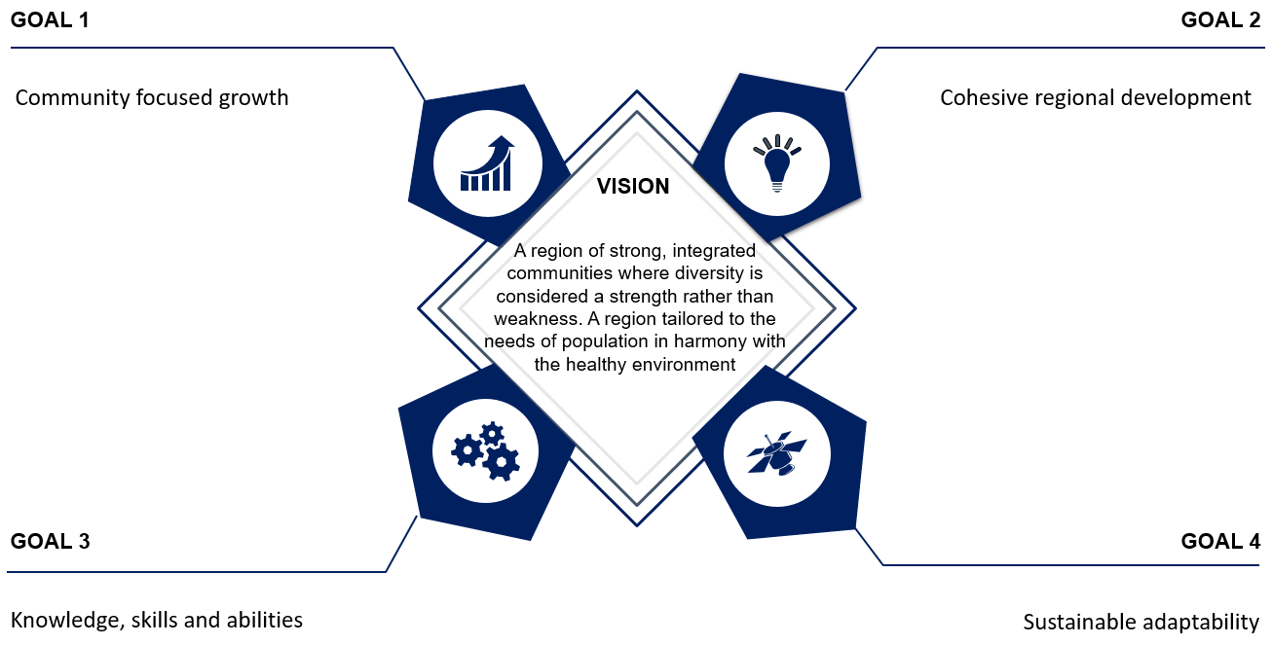
Picture 35: Vision and strategic goals of the SAA-2027

DEVELOPMENT PILLARS
In defining the vision and strategic goals, and taking into account the specific development strategies of each member, as well as the results achieved by the Alps – Adriatic Alliance in the past, three pillars for the SAA-2027 have emerged:
- Diversity
- Connectivity
- Sustainability


Picture 36: Development pillars of the SAA-2027

Diversity – in order to support growth and development in all members, a coordinated and integrated development approach is necessary. This pillar is based on the assumption that all of the members are aspiring intercultural cooperation as a common core value, as well as interregional cooperation as a tool for focusing the ability to compete nationally and internationally and to enable higher quality of life for its inhabitants.
Connectivity pillar focuses on strengthening the capacities of members through improved interconnected networks in all important development areas as a key prerequisite to achieve stabile development and prosperity.
Sustainability as a pillar in this Strategy focuses on the member’s capacity to achieve development that incorporated sustainable environment, society and economy in balanced ratio. In order to achieve this, the sustainability pillar builds upon the active approach to the development needs of members and on the fact that there is a significant will to change attitude in all members.

INTERVENTION LOGIC
Analysis of the development documents of the members, as well as the monitoring of global development trends has shown that the fast track changes in the area of new technologies, new management models, energy, education, tourism, culture, contemporary Art and Culture scene with an special view to cultural heritage, as well as in other areas of human development are actually representing new possibilities that members could jointly utilize in order to ensure development and advancement.
Furthermore, in order to achieve its vision and the development goals, members need to mobilize their creative human potentials and to invest into new jobs with higher added value. At the same time, the members need to jointly work on achieving sustainable connection among scientific, civil, public, social, health, education and cultural sector in order to increase the well-being of the population in the Alps – Adriatic area and to support feasible economical and civil development.
It needs to be additionally highlighted that all, in order to ensure the success of the SAA-2027, all these areas need to be viewed in the frame of interregional and/or international cooperation.
As identified before, this will be achieved throughout 3 strategic development goals which will contribute to the achievement of the development vision. These goals will be achieved throughout the implementation of the following intervention logic of the SAA-2027:

: 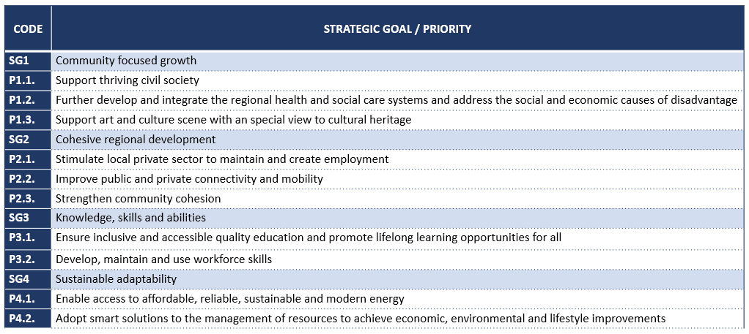
Table 1: Vertical intervention logic of the SAA-2027

SAA-2027 AGENDA

COMMUNITY FOCUSED GROWTH

Community focused growth covers a number of high priority growth areas, which will be subject to special attention in the Alps – Adriatic region in future years. These areas have been identified in the development strategies of members and they apply to natural and cultural heritage, health and social care systems and enhancing civil society development of members. These areas are identified in line with the development efforts shared by all members, which have been recognised during the analysis of main development strategies of each member.
With the focus on these areas, the SAA-2027 will inspire, facilitate and support uniform development of communities of members and it will motivate the transition which must occur in order to create growth in members in future years.
In connection to the previously identified development pillars, it is visible that the Strategic objective 1 – Community Focused Growth is systematically distributed throughout all three development pillars, and thus it is an important factor contributing to the achievement of the development vision:
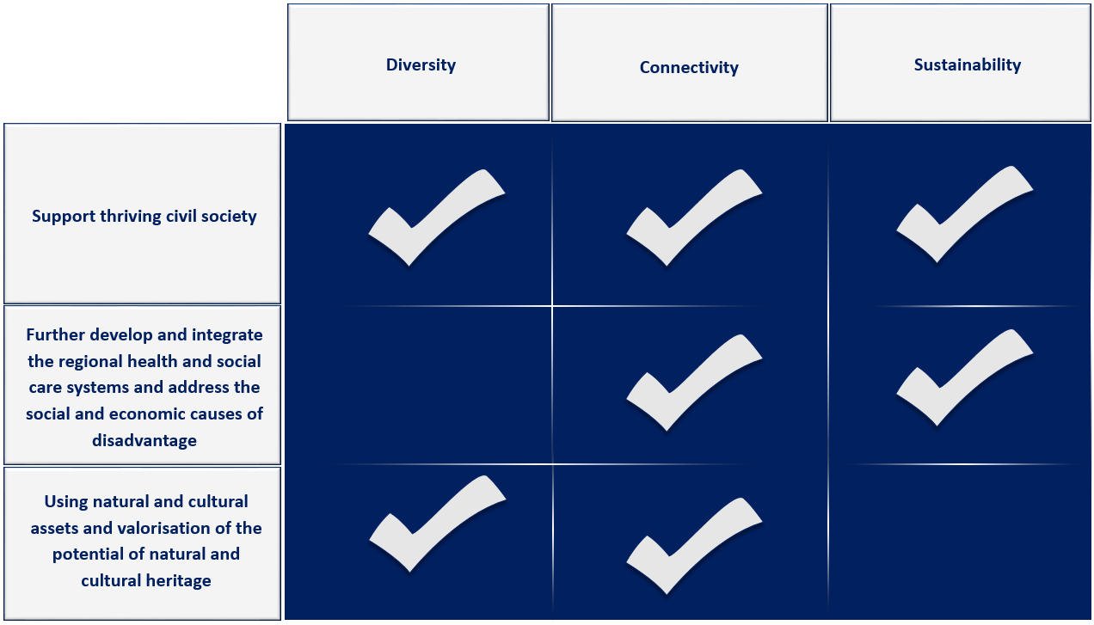
Picture 37: Representation of the development pillars in the Strategic goal 1

Support thriving civil society
The strategic priority Supporting thriving society is directed towards the creation of dynamical and encouraging communities which respects the individual and gives him the possibility of personal affirmation. This strategic priority aims to increase the quality of life in members as wells as to encourage greater engagement of civil society, mostly by improving the conditions and the work quality of civil society organisations, developing better connection between civil society and public administrations, improvement of volunteering programmes and promotion of socially useful work and volunteering as a way of life.
EXAMPLES OF ACTIONS
- Networking and knowledge transfer between civil society stakeholders
- Strengthening of competences of civil society stakeholders
- Development of innovative models for further development of civil society and inclusion of all age groups into the civil society activities
- Promotion of the role and importance of the civil society in local communities
- Encouragement and promotion of volunteering activities
- Strengthening the cooperation between civil society, business sector and/or public administration

Further develop and integrate the health and social care systems and address the social and economic causes of disadvantage

The priority Further develop and integrate the health and social care systems and address the social and economic causes of disadvantage is directed towards increase of the living standards of inhabitants of members and establishment of equal living conditions and equal employment opportunities of disadvantaged groups of population. Through the investments into health and social care system, promotion of healthy living habits, prevention activities and creation of the tailored-made health and social care, improved inclusion of disadvantage groups in the community life and on the labour market will be ensured.
Furthermore, the priority is directed towards increased quality of services in the health and social sector, as well as introduction of tailored programmes for disadvantaged groups in order to enable their active participation in the community life. The implementation of the activities inside this development priority will ensure better availability and higher quality of the health and social services as well as better inclusion of local population (especially disadvantaged groups) into the labour market and community life. All these activities together will ensure the realisation of human and civil rights of each individual and, through this, it will contribute to the achievement of identified development vision.

EXAMPLES OF ACTIONS
- Improving existing and developing new services in the health or social care sectors
- Systematic strengthening of competences in the health or social care sectors
- Modernisation of the health or social care sectors via ICT or up-to-date approaches to providing services
- Tailoring the health or social care sector services to the needs of users, especially users from one or more disadvantaged groups
- Development and implementation of different prevention activities in the health care or social care sectors
- Awareness rising and protection of the rights of the users of health care or social care services
- Networking and knowledge exchange between institutions active in the health care and social care sectors
- Development of the professional rehabilitation systems
- Support to the workplace adaptation and development of support activities for employment of disadvantaged groups
- Awareness raising of employers and general public about the challenges that are disadvantaged groups facing into their everyday life
- Promotion opportunities for disadvantaged groups on the labour market
- Awareness rising of target groups about the realisation of human and civil rights of every individual

Using natural and cultural assets and valorisation of the potential of natural and cultural heritage

The members enjoy extraordinary natural and cultural treasures, resources and values which play a significant role in defining its identity as well as in achieving balanced development of all communities. Promotion of these natural and cultural assets and valorisation of the potential of natural and cultural heritage remains one of the core motions of all members, with special regard to intercultural dialogue.
The SAA-2027 will support active involvement of all groups of the society in cultural life or local communities, as well as on regional, national and especially on interregional level. Furthermore, this priority is directed towards increasing the capacities for the development of cultural and creative industry, participation of different target groups in culture and art, preservation of rich cultural heritage and valorisation of prosperous cultural potentials of members. This will not only contribute to the position of the Alps – Adriatic region on the cultural and creative industry market, but it will also contribute to the creation and recognition of the cultural identity of the whole Alps – Adriatic region.
Furthermore, this priority aims at achieving sustainable economic and territorial development of members by exploiting the natural and cultural assets/heritage of members while at the same time preserving them and /or increasing their tangible and intangible values. Particular attention will be given to the valorisation or protection of natural and cultural heritage by diversification of the economy of communities by using this heritage in a sustainable way – by protecting and enhancing them at the same time.
EXAMPLES OF ACTIONS
- Encouraging protection, valorisation and management of cultural and/or natural heritage for the purpose of tourism development as well as the development of other economic branches
- Support to institutions active in the field of culture and/or nature
- Support to the promotion of cultural, creative and artistic activities
- Encouraging education and promotion of knowledge and skills linked with the cultural and/or natural heritage as well as natural and/or natural assets
- Networking of different stakeholders actively participating in the management of nature or culture
- Promotion of sustainable management of cultural and natural assets
- Fostering economic development of the region through sustainable tourism development or the development of other activities based upon protection, promotion or valorisation of natural and cultural heritage and assets
- Decreasing the human pressure to natural and cultural heritage sites

COHESIVE REGIONAL DEVELOPMENT

Each member is facing its own development challenges. Most of the members are facing the challenge of migration as well as emigration of population from rural areas into urban areas. This process is typical especially in the communities characterised with weaker living standards, where inhabitants lack benefits offered by more developed communities.
As stated earlier, the Alps – Adriatic region geography includes a wide range of urban communities of different size and rural areas, each with their own strengths and challenges. However, there is close interaction and mutual dependency between those communities, especially urban communities and their surrounding areas, which may cause the development of interconnected Alps – Adriatic region.
In order to minimize the development differences between members, this strategic objective will, through the implementation of three strategic priorities, support the development of solutions that will contribute to the achievement of homogenised development of members and reduce the development gaps between members, respecting at the same time diversity and identity of each member. This strategic goal intent to create the bond between members. As well, in order to achieve cohesive development, it will support establishing of partnerships between educational institution, cultural life, private sector and public institutions in order to maximise the potential of members to manage development in cooperation with neighbouring members.
The development priorities identified under this strategic goal also include development pillars identified for the Alps – Adriatic region in a way that these pillars are evenly distributed across the development priorities as follows:
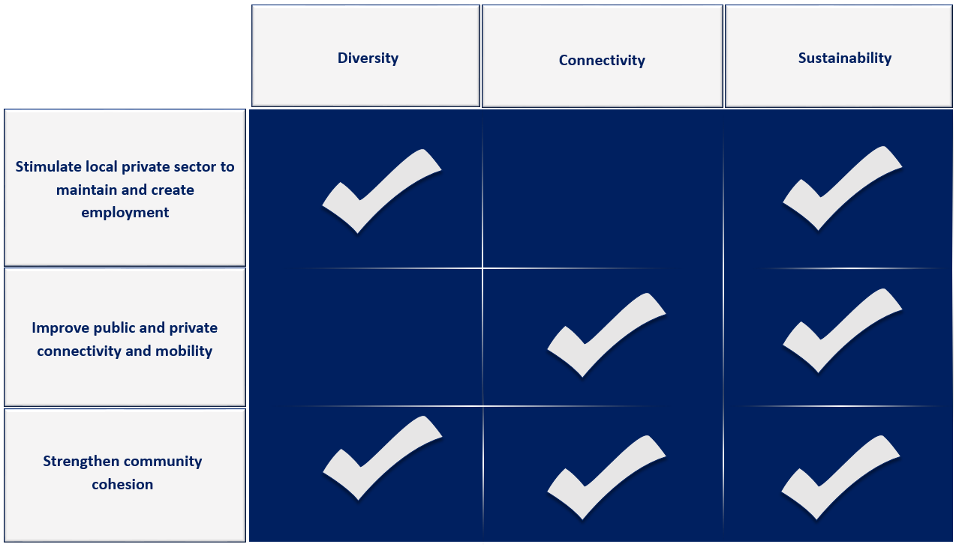
Picture 38: Representation of the development pillars in the Strategic goal 2

Stimulate local private sector to maintain and create employment

Activities that support and develop the growth of existing businesses, as well as ensuring the climate that enables establishment of new businesses and industries with higher added value and increasing export capacities of members will be supported via this development priority.
This development priority is also directed towards self-employment, development of leadership and business skills, directing factors that limit private sector growth, support the development of small and medium size enterprises, stimulate and enable entrepreneurship, all in order to support creation of local jobs and develop strong and diverse economy of members.
Furthermore, this priority is intended to promote the importance of entrepreneurship as a driver of economic development, raising the employability of local population and increasing the rate of work active population. Furthermore, this priority is directed towards entrepreneurship of disadvantaged groups in line with the market needs and the development of social entrepreneurship as well as promotion of principles of socially responsible entrepreneurship in order to ensure harmonisation of entrepreneurship and local community needs.
EXAMPLES OF ACTIONS
- Supporting and promotion of internationalisation of enterprises
- Providing advisory support for entrepreneurs
- Development and implementation of entrepreneurial educational programmes
- Improvement of existing and/or development of new programmes and measures for entrepreneurial development especially programmes and measures directed towards computerisation of business processes, export and creating new workplaces
- Further development and strengthening of business support institutions
- Encouragement of self-employment in line with needs of members
- Modernisation of existing and development of new entrepreneurial support programmes, with emphasis on disadvantaged groups

Improve public and private connectivity and mobility

This priority is directed towards strengthening public and private transport connections inside and outside members, as well as promotion of mobility of goods, people and workforce between members. The activities implemented in the frame of this development priority will help to increase the transport accessibility of the Alps – Adriatic region and they will support the development of efficient transport and mobility systems. Through the support to mobility inside the members, with special effort to achieve dynamic connectivity between all members, an increase in productivity will be achieved, which is one of pre-conditions for sustainable development.
Furthermore, all members have identified the challenge of connecting rural communities that can be in disadvantaged position by virtue of their remote location from a range of facilities and essential services that are often available only in urban areas. This advantage can be lessened by innovative use of existing services and the application of new and developing technologies.
The initiatives implemented as part of this development priority will improve access to employment, health, education, social and recreational services for people, which is one of the main assumptions that needs to be satisfied in order to achieve the vision of the SAA-2027.

Strengthen community cohesion
EXAMPLES OF ACTIONS
- Promoting integrated rural transport initiatives which meet the needs of those living in isolated areas and in particular elderly and disabled people
- Improve the overall connectivity of rural communities to services and other parts of the Alps – Adriatic region by exploring innovative ways of bringing these services to the communities
- Establishment of organisational, management and logistical support to connectivity and mobility
- Modernisation and further development of connectivity and mobility initiatives
- Enhancing the security levels of existing connectivity and mobility initiatives
- Awareness rising on existing connectivity and mobility initiatives, future plans, benefits and importance of those initiatives, as well as challenges and possible solutions connected with them

Although this development priority has not been directly identified in any of analysed development strategies of members, as it is the case with all other, it is of utmost importance to include it into the SAA-2027. This priority rests in the centre of the development efforts of all members when it comes to the cooperation.
Namely, the analysis of the development documents has shown that the main characteristic of all members is the diversity of people, backgrounds and circumstances. In order to change this into advantage, this diversity should be appreciated and positively valued, i.e. this development priority is directed towards strengthening community cohesion.
Strengthening community cohesion will enable that all those from different backgrounds have similar opportunities in the Alps – Adriatic region and that strong and positive relationships are developed between different groups. This is best done through encouraging interaction, fostering mutual respect and understanding.
Strengthening community cohesion will be best achieved through encouraging cooperation, mutual support and solidarity, fairness and equal treatment in all aspects of community life. In other words, this development priority will be directed towards networking, cooperation and joint undertakings in all sectors, as well as through the promotion of higher values such as corporate social responsibility, equal employment opportunities or “user-friendly” public services.
In order to ensure best achievement of this priority, and at the same time to respect is specifics, the small-scale projects supported through the calls published directly by the Alps – Adriatic Alliance will be implemented as a part of this priority.

EXAMPLES OF ACTIONS
- Supporting the development of social entrepreneurship
- Raising awareness about the principles of socially responsible entrepreneurship
- Encouraging the networking c cv cohesion principles into training and educational activities
- Increasing capacity of target groups, especially decision makers in different sectors for incorporating community cohesion into their daily activities
- Promoting intergenerational exchange of knowledge, skills and practices
- Encourage cooperation of educational institutions, private and public sector
- All small-scale projects in line with the working programme, mission and vision of the Alps – Adriatic Alliance

KNOWLEDGE, SKILLS AND ABILITIES

Access to a highly qualified workforce and effective knowledge environments has been identifies as crucial to growth and development by all members. This also includes stronger collaboration of educational and knowledge institutions, public authorities, employment institutions, private sector and other various parties in order to establish high level of knowledge, skills and abilities of populations.
All these institutions wish to secure an appropriate, highly qualified workforce and knowledge which will contribute to job creation and this to the growth and development of members. This need is also backed up with the trends on the labour market which is characterised with the increasing need for skilled workers, especially in the sector of industries with the higher added value (especially in highly urbanised areas).
All members are ambitious to enhance competitiveness, create growth, ensure development, and generate more and new jobs. This, at the same time demands adequate and qualified workforce. In order to ensure competent workforce, all relevant institutions must be given adequate opportunities to cooperate on new knowledge and educational methodologies.
Furthermore, there is the need to increase the focus on the need for skilled labour. This will make it possible to create skilled and highly trained workforce across the whole Alps – Adriatic region. As well this needs to be achieved throughout formal, non-formal and informal education as well as incorporating lifelong learning principles into the professional life of population. One of the main conditions to ensure the skilled workforce is availability of education to all groups on one hand and cohesive and innovative education system which ensures useful knowledge, skills and qualifications on the other hand, regardless where this workforce is placed.
All these activities joined together under this strategic goal will make the Alps – Adriatic region an attractive place to work and settle with favourable conditions for international employees and their families, and thus support the achievement of the defined development vision.
As in previous cases, this strategic goal also includes all three defined development pillars of the Alps – Adriatic region, which ensures that the development efforts are tailored to the needs and specific of the whole region:

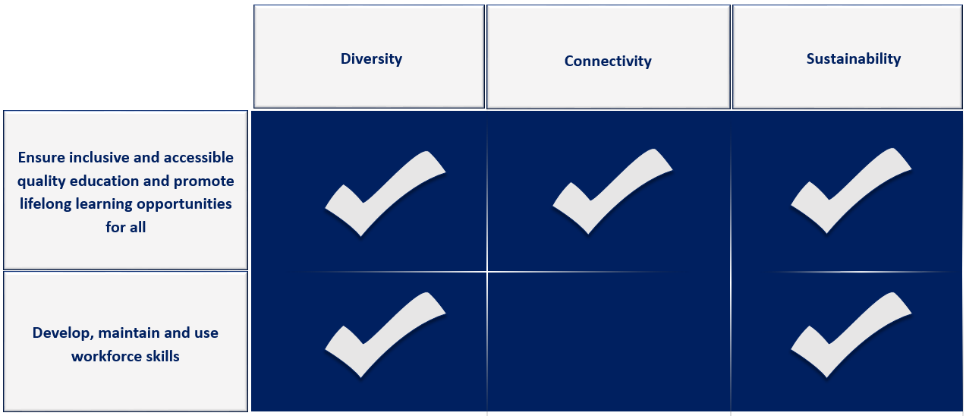
Picture 39: Representation of the development pillars in the Strategic goal 3

Ensure inclusive and accessible quality education and promote lifelong learning opportunities for all

This development priority will support creative and innovative educational methodologies and their incorporation into all educational processes implemented in the Alps – Adriatic region. As a result of this process, the priority will strengthen the human capacities in the educational sector and establish conditions for modernisation and development of tailored education methodologies and practices. Among others, this will contribute to the establishment of the knowledge based society in the whole region, which is one of the core competitiveness factors.
Furthermore, in order to become this knowledge based society, it is necessary to ensure that the educational system is inclusive and accessible for all stakeholders and that, at the same time, it tackles the major changes and needs of the labour market. A large role here is played by modernisation, popularisation and competent vocational education and training of individuals as a part of formal, informal and non-formal education.
Due to the fact that today’s society, especially entrepreneurial sector, is characterised by the rapid change and constant growth of the knowledge base, it is necessary to incorporate lifelong learning doctrine into the professional development of each individual.
All these factors combined will enable members to ensure skilled, mobile and adjustable workforce and to ensure the baseline for growth and development, in line with the defined development vision.
EXAMPLES OF ACTIONS
- Support to the modernisation of the educational system
- Application of new technologies and methodologies in the educational process
- Upgrade or development of quality management system in education
- Introduction of e-learning principles in all educational niches
- Encouraging extracurricular activities
- Supporting disadvantaged groups throughout the whole educational process in all forms of education (formal, non-formal and informal)
- Identification of the work with gifted students and incorporating the newest trends in the work with these students
- Support to the establishment of centres of excellence
- Encouraging all forms of lifelong learning, especially those directly linked with the labour market needs
- Increasing the competencies of educational institutions and public administrations responsible for educational sector for modernisation, further development and tailoring of the educational practices and processes in order to ensure harmonisation with the labour market needs
- Modernisation of the vocational training and education
- Promotion of vocational education and its benefits among potential students (also in the frame of the lifelong learning)
- Supporting cooperation among education, research, private and public sectors in order to produce skilled workforce in line with the current needs and demands of the market

Develop, maintain and use workforce skills
This development priority is directed towards initiatives that help develop, maintain and fully utilise the skills needed for industries to thrive, particularly in areas where there is a noticeable shortage of skilled workforce.
In order to fully implement this development priority, initiatives related to the improving research on the industry needs, workforce collaboration in order to additionally capitalise on existing education and training opportunities. As well, this development priority promotes the creation of new partnerships among different institutions as well as activities designed to attract skilled workers in order to meet the needs of members and at the same time improve work readiness.
All these activities jointly will enable members to ensure skilled workforce in order to support their economy, which is a cornerstone of sustainable development.
EXAMPLES OF ACTIONS
- Exchanging of knowledge and best practices between different stakeholders and education and training systems dealing with the creation and exploitation of skilled workforce
- Expanding opportunities for learning mobility of the workforce
- Encouraging job shadowing and workforce exchange programmes
- Promoting establishment of distance learning and training programmes
- Supporting activities related to the harmonisation of private and professional life of an individual
- Providing the tools and methodologies for continuous monitoring and predicting the needs of the labour market

SUSTAINABLE ADAPTABILITY

Each member has, in its development strategy, expressed the aspirations towards sustainable adaptability, i.e. planning its development in such a way that the whole region develops taking into account that the environmental and natural resources have not been over-burdened. Each member strives to establish development processes that will ensure increased production (and with this connected consummation) but at the same time these processes should ensure reduced pressure on the environment and common natural resources (such as food, energy, raw materials, water…).
This strategic goal is focused on the fact that the demand for alternative processes and products (especially in the energy sector) is global, while the resources are limited. Therefore, in order to thrive, the Alps – Adriatic region needs to make the most of the resources available to it, with a great emphasis on cooperation and knowledge exchange among members.
This strategic objective supports the development and/or modernisation of models and initiatives aiming at utilising resource efficiency while avoiding waste, balanced energy systems based on renewable energy sources and energy sources, climate adaption and ground water protection. All this combined together will provide solid foundation for sustainable development.
This strategic objective is divided into two main development priorities that are based on the development pillars of the Alps – Adriatic region, ensuring through this also the agreement with the development efforts of each member individually as well as with the Alps – Adriatic region as a whole:
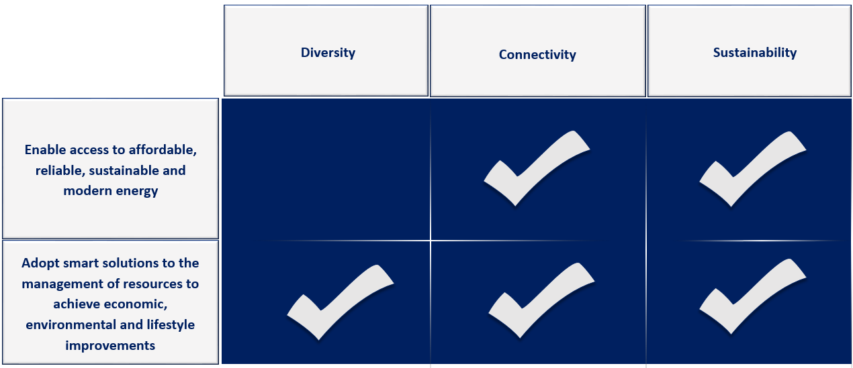

Picture 40: Representation of the development pillars in the Strategic goal 4

Enable access to affordable, reliable, sustainable and modern energy

The access to affordable, reliable, sustainable and modern energy demands access to energy based on clean fuels and technology, improved energy efficiency and significant share of renewable energy sources used for energy production. This understands implementation of robust, comprehensive and sustainable activities directed towards promotion of reliable and secure sources of energy for communities in all members. These activities need to be carefully planned, in order to avoid adverse effects on environment – meaning that all activities need to balance negative impacts against the potential benefits.
Nevertheless, it is clear that there is a need to significantly increase all renewable energy ratios in the overall energy mix, as well as increase energy efficiency in genera. This has also been recognised by all members in their development documents and has been pointed out as an area that requires special attention.
Therefore, this investment priority is directly connected with decreasing energy consumption (which will directly reduce the greenhouse gas emission and raise energy efficiency) as well as increasing the production of energy from clean and/or renewable energy sources.
All these activities together will ensure development of all members in line with the main sustainability principles and with this it will ensure the achievement of the development vision.
EXAMPLES OF ACTIONS
- Increasing awareness on the importance, benefits and potentials of renewable energy sources
- Promoting development and deployment of technologies linked with the clean energy and/or energy efficiency
- Facilitating the exchange of best practices in the area of promoting renewable energy sources and/or energy efficiency
- Supporting activities linked with the promotion of high energy performance of buildings, energy efficiency as well as environmentally-friendly transport
- Promoting energy education and energy efficiency in households, private and public sector
- Encouraging systematic energy management in households, private and public sector
- Support the development and implementation of plans and programmes linked with the energy efficiency and/or usage of renewable energy sources

Adopt smart solutions to the management of resources to achieve economic, environmental and lifestyle improvements

Changes in the population distribution, household formation, development of local communities and the lifestyles of population in all members continue to put increased pressure on the limited resources. Combined with the climate change, this has a significant impact on the current and future discrepancies between resource demand and availability, leading to the potential for lack of available resources and increased pressure on the environment. Implementing smart solutions linked with the management of limited resources is both, a practical and environmental necessity for the development.
This development priority is intended to establish more qualitative resource management operations in order to preserve, protect and sustainable use limited resources available (water, soil, air), available to members. This will have direct impact on the economic development of the whole Alps – Adriatic region as well as on the achievement of the identified development vision.

EXAMPLES OF ACTIONS
- Supporting resource use within the carrying capacity and resilience of the environment
- Promoting integration of traditional ecological knowledge with modern science in order to develop more effective resource management practices
- Exploring new forms of resource management systems
- Encouraging the development of local communities and local revitalization using the principles of sustainable resource management
- Stimulate the introduction of environmental protection standards in all activities of local communities
- Implementation of activities linked with the education and awareness rising of different target groups on the importance of preserving natural resources

HORIZONTAL AREAS

During the creation of the SAA-2027, a significant attention has been given to the identification and incorporation of horizontal areas into all strategic goals and development priorities. The same will be done also during the implementation of the SAA-2027.
As stated earlier, there are two main horizontal areas identified during the process of the creation of the SAA-2027:

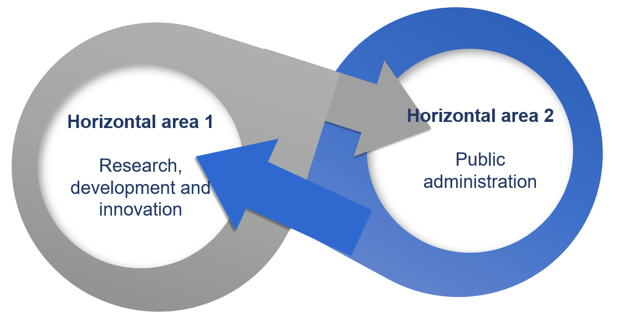
Picture 41: Horizontal areas

RESEARCH, DEVELOPMENT AND INNOVATION

The SAA-2027 aims to create the general conditions in which members can take initiatives and exploit their ideas and opportunities. Nonetheless, this Strategy needs to trigger cross-sectoral initiatives linked with the raised levels of research, development and innovation as a driver of growth and productivity.
Therefore, the SAA-2027 will entail actions across all strategic goals and development priorities supporting knowledge creation, growing and accessing new opportunities, promoting the development potentials of members and sourcing capital. The emphasis will be on maximising existing development efforts and supporting new and existing practices to innovate in order to drive sustainable growth.
The research, development and innovation, as a horizontal area, will be incorporated into all sectors linked with the development in order to ensure the development that is following up to date trends, methods and practices in areas covered by identified strategic goals and development priorities. This will ensure continued economic and social progress of members without significant threatening of natural and environmental resources that are important to the local communities.

PUBLIC ADMINISTRATION

Public administration has been identified as a horizontal area in order to ensure participative approach between institutions responsible for the administrative management of members and stakeholders active in each sector included into this Strategy. It is expected that such an approach will encourage stronger social – economic development of members and the Alps – Adriatic region as a whole.
Including public administration as a horizontal area will support cooperation of all sectors important for the development of the Alps – Adriatic area – economic, civil and public. This will also ensure general baseline for economic, social and territorial cohesion and the preservation of diversity and identity of members which are considered as strength and not an obstacle.
Furthermore, including public administration into all development areas defined in this Strategy is indispensable in the process of long-term planning of sustainable development of the Alps – Adriatic region and it will ensure the achievement of expected goals.

INDICATORS

GENERAL INFORMATION ON SELECTED INDICATORS

The implementation of the SAA-2027 is based on the monitoring and evaluation approach, which enables providing feedback on the actual higher level strategic goals and pillars as derived in the SAA-2027. In order to achieve feedback and evaluate the SAA-2027, an indicator framework has been developed. These indicators are suggested measuring instruments for development against which the success of the SAA-2027 can and will be measured.
The proposed indicators are quantitative and qualitative variables that attempt to provide reliable and realistic means to measure achievement of the goals and priorities defined in the SAA-2027. Furthermore, since indicators are developed on a goals and priority levels, they are measuring and monitoring progress with the respect outcome indicators. Based on these measuring and monitoring, the indicators will be used to provide feedback on the areas where targets have been reached and areas where targets have not been met – in order to identify where and at what level improvements may be required.
In order to ensure successful and realistic monitoring of the SAA-2027 implementation, defined sets of goals and priorities is translated into a priority specific set of measurable outcome indicators.
The criteria for selecting appropriate outcome indicators was based on the relevance of the indicators, how clear and unambiguous indicators are, the availability of indicators and how adequate indicators are to provide a sufficient base to assess performance. The criteria were also based on the reliability, accuracy, accessibility and timelines of the indicators.

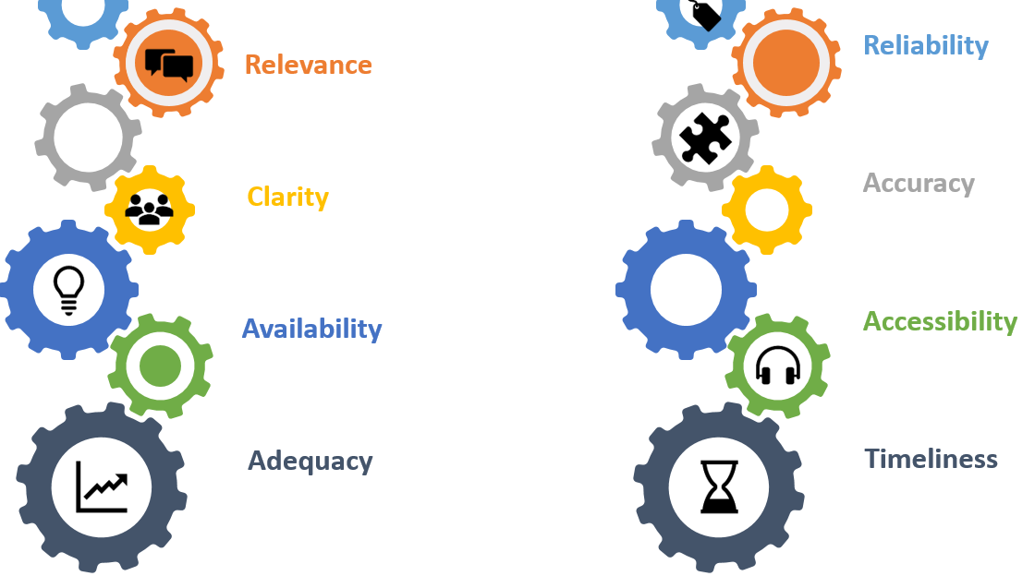
Picture 42: Indicator selection criteria

The quantitative indicators selected are based on the reporting in terms of the number or percentage. The qualitative indicators imply qualitative assessment, compliance with quality or obtaining objective information on actual progress that will contribute to the better-informed strategic decisions linked with the SAA-2027 implementation.
Within the process of indicator definition for each priority, the interest of multiple stakeholders and multi-sectoral interests have been taken into account. This selection process strived to select usable and appropriate outcome indicators. Thus, the indicators have been selected in such way that they are relevant across multi-sectors, cover the core thematic areas of the SAA-2027 focus and address the concerns of multiple stakeholder groups.
In order to facilitate the process of the translation of priorities into a set of measurable outcome indicators, two types of outcome indicators have been defined:
- Selected indicator
- Possible other indicator.
The “selected indicator” serves as the core measurement of the priority, while the “possible other indicator” serves as an additional indicator for more accurate measurements – if available in the given moment.
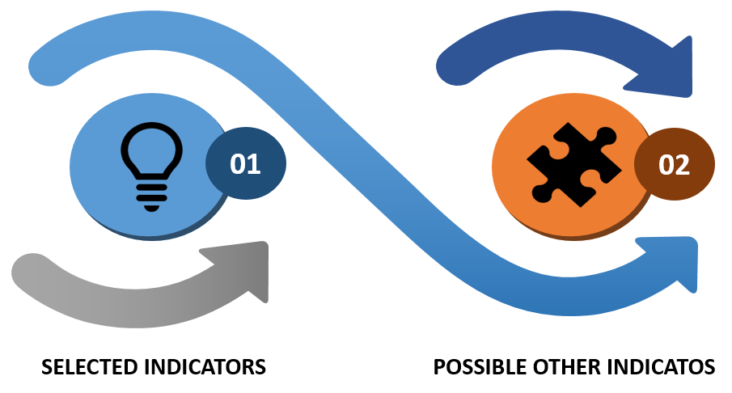
Picture 43: Types of indicators

INDICATOR FRAMEWORK

Strategic Goal | Priority | Outcome | Selected Indicators | Possible Other Indicators
Community focused growth | Support thriving civil society | Dynamical and encouraging communities  Established possibilities for personal affirmation | - Number of civil society initiatives | - Ratio of inhabitants included in the volunteering actions
Community focused growth | Further develop and integrate the regional health and social care systems and address the social and economic causes of disadvantage | Increased living standards of inhabitants  Establishment of equal living conditions | - Number of modernised or newly established health and social system care services  - Coverage rate with the high speed internet access | - Number of health and social care services directed towards rural or distant areas  - Number of inhabitants
Community focused growth | Support art and culture scene with an special view to cultural heritage
Cohesive regional development | Stimulate local private sector to maintain and create employment | Development of growth of existing businesses  Positive climate that enables establishment of new businesses and industries | - GDP per capita  - Unemployment rate | - Number of supported entrepreneurs  - Number of financial instruments for entrepreneurs  - Number of entrepreneurs actively using the financial instruments for entrepreneurs  - Number of entrepreneurial supporting institutions
Cohesive regional development | Improve public and private connectivity and mobility | Strengthening public and private transport connections – internal and external  Promotion of mobility of goods, people and workforce | - Number of km of modernised or newly developed transportation routes | - Number of people using public transportation
Cohesive regional development | Strengthen community cohesion | Ensuring similar opportunities of inhabitants in Alps – Adriatic region  Development of strong and positive relationships between different groups | - Number of supported small scale projects | - Number of approved projects from different EU funds supported through the measure covering project preparation costs
Knowledge, skills and abilities | Ensure inclusive and accessible quality education and promote lifelong learning opportunities for all | Developing and supporting innovative and creative educational methodologies and their incorporation in all educational processes | - Number of new formal, informal and nonformal educational programmes  - Number of participants in new formal, informal and nonformal educational programmes | - number of educational institutions adopting new educational processes and practices  - rate of adult learners in formal educational programmes
Knowledge, skills and abilities | Develop, maintain and use workforce skills | Reduce labour market disparities  Fully utilise the skills needed for industries to thrive | - Number of participants in the specialised vocational and educational training programmes in accordance with the labour market needs | - Number of pre-qualified labour market participants in accordance with the labour market needs
Sustainable adaptability | Enable access to affordable, reliable, sustainable and modern energy | Access to energy based on clean fuels and technologies  Improved energy efficiency  Increased share of renewable energy sources used for energy production | - Ratio of renewable energy sources in energy production  - Amount of investments in energy efficient public buildings | - Decrease of energy consumption  - Number of implemented measures (soft and hard)
Sustainable adaptability | Adopt smart solutions to the management of resources to achieve economic, environmental and lifestyle improvements | Establishment of more qualitative resource management operations | - Tons of recycled waste  - Number of wastewater treatment plants  - Ratio of households connected to sewage systems  - Ratio of households connected to water supply systems | - Number of investments in ecological and/or integrated production  - Number of actions in the field of civil protection and/or protection and rescue
Table 2: Defined indicators per priority

MONITORING AND EVALUATION

Monitoring and evaluation of the SAA-2027 will be carried out both at the level of the individual projects and at the level of the Strategy as a whole.
The monitoring and evaluation system of the SAA-207 is developed in a way that is consistent with the usual working procedures inside the Alps – Adriatic Alliance. If the praxis shows the need for further evolvement of the monitoring and evaluation system, the elements of this system will be jointly defined by the General Secretariat and TCP-s.

INDIVIDUAL PROJECT LEVEL
The individual project level is applicable to the small scale projects that are implemented in the frame of the Priority 2.3. Strengthen community cohesion. Those are projects that are supported directly through the Alps – Adriatic Alliance call for proposals. The reporting procedure and the report content will not be changed and they will follow established protocols for these small scale projects.

GENERAL STRATEGY LEVEL

The main body responsible for monitoring and evaluation of the SAA-2027 is General Secretariat of the Alps – Adriatic Alliance. The General Secretariat will implement monitoring and evaluation procedures in closely cooperation with all members and Thematic Cooordination Points (TCP-s) established under the Alps – Adriatic umbrella.

Evaluation of the indicators

In order to do so, the General Secretariat will, in close cooperation with a presidency member, report to the Alps – Adriatic Steering Committee. The General Secretariat will produce Yearly Reports containing information on the SAA-2027 implementation. The yearly report will be prepared at the end of each financial year. In order to gain necessary information, the General Secretariat will invite all TCP-s to submit their yearly report, linked with the thematic area for which each TCP is responsible. The reports will be submitted via the standard reporting template generated by the General Secretariat.
Furthermore, in order to ensure transparent implementation of the SAA-2027, the General Secretariat will place the annual report on the webpage.
The yearly report will include, at least, following information:
- Projects, activities and plans implemented in connection with the SAA-2027
- Results achieved – contribution to the defined goals of the SAA-2027
- Immediate indicators achieved
- Stakeholders involved
- Role of the Alps – Adriatic Alliance or its members
- If necessary, proposed activities to carried out to improve the impact of the SAA-2027.
The yearly report will contain both qualitative and quantitative indicators.

Evaluation of the SAA-2027 document

Furthermore, the General Secretariat will also carry out periodic evaluation of the applicability of the SAA-2027 on the development needs of members. This will be done in accordance with all members of the Alps – Adriatic Alliance.
The evaluation will be done in accordance with the methodology decided jointly upon the members under the guidance of the General Secretariat.
Based on the report on this process, the members will then decide on the future of the SAA-2027: will it be implemented further, will it be adjusted to the changing needs of members or if it will completely be replaced by another strategic document.
If the strategy will need adjustment or replacement, the General Secretariat, in cooperation with the Steering Committee will decide on the organisation that will be responsible for leading this process.

CONNECTION TO TCP-S

In order to establish the connection of the SAA-2027 document and its implementation with the regular work of the members of the Alps – Adriatic Alliance, the TCP framework has been developed as a part of this document.
Currently, the Alps – Adriatic Alliance has 13 TCPs established:
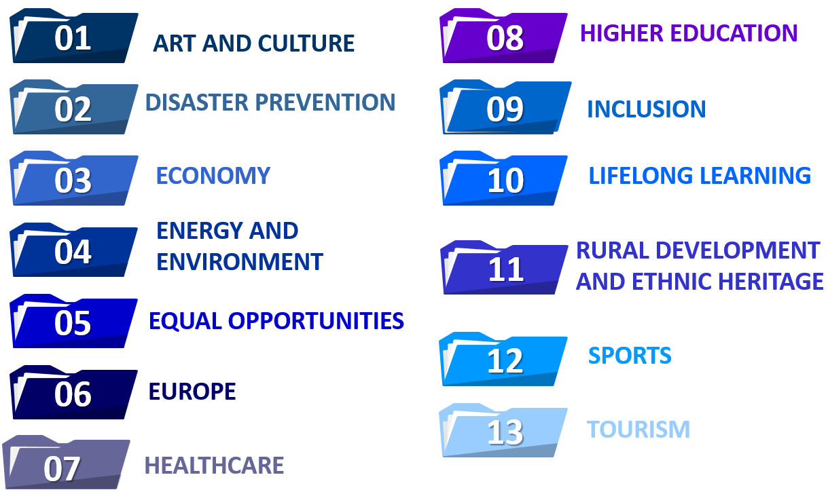
Picture 44: Currently established TCPs in the Alps – Adriatic Alliance

The objective of the TCPs is the establishment and support of thematic networks of players at different levels, and to develop and to carry out common projects. TCPs are established for a minimum period of two years by the Alps – Adriatic Council. The Alps – Adriatic Council can extend the TCP as well.
Since the areas for each TCP is responsible can be also found under the priorities and strategic objectives of the SAA-2027, it is logically that the work of TCPs is directly linked with this strategic document.
The document is directed towards establishing the base of cooperation between members of the Alps – Adriatic Alliance in order to find common solutions for common challenges. Therefore, the work of the TCPs in fully compatible to the SAA-2027.
In order to maximise the impact of the TCPs on the implementation and achievement of output indicators defined, the role of TCPs in of utmost importance. Since they are direct connection between different types of stakeholders across the Alps – Adriatic region in their field of expertise and the implementation of the SAA-2027, it is necessary to include them directly into the implementation process. This is done through the development of the network of TCPs across the strategic goals and priorities of the SAA-2027.
In order to do this, each priority will have one TCP responsible for it. This TCP will coordinate all activities linked with the preparation of projects, plans and/or activities linked with this priority.

Furthermore, since the areas of expertise of TCPs is overlapping in some priorities, in order to ensure harmonisation of the work among TCPs, for these priority is only one TCP defined as the coordinator, while other TCPs are having the supporting role. This means that the coordinator TCP is directly cooperating with other supporting TCPs on the field in order to ensure higher quality of their work. This vertical hierarchy is established, not to eliminate other TCPs, but to decrease the number of communication channels between stakeholders in the field and TCPs. In other words, such organisation of work guarantees higher quality, better support and less room for misunderstanding.
The network of TCPs and across the strategic goals and priorities defined in the SAA-2027 is given in the following table.

 | Art and culture | Disaster prevention | Economy | Energy and environment | Equal opportunities | Europe | Healthcare | Higher education | Inclusion | Lifelong learning | Rural development and ethnic heritage | Sports | Tourism
SG1
P1.1. | Support |  |  |  | Support |  |  |  | Coordinator |  |  | Support
P1.2 |  |  |  |  | Support |  | Coordinator |  |  |  | Support | Support
P1.3 | Coordinator |  |  |  |  | Support |  |  |  | Support |  |  | Support
SG2
P2.1 |  |  | Coordinator |  |  |  |  |  | Support |  | Support |  | Support
P2.2 |  | Support | Support | Support |  | Coordinator
P2.3 | Small – scale projects – all TCPs responsible in accordance with their role in the work of Alps – Adriatic Alliance
SG3
P3.1 |  |  |  |  | Support |  |  | Coordinator | Support | Support
P3.2 |  |  | Support |  |  |  |  | Support |  | Coordinator |  |  | Support
SG4
P4.1 |  | Support |  | Coordinator |  | Support |  |  |  |  | Support
P4.2 |  | Coordinator |  | Support |  |  | Support | Support
Table 3: Responsibilities of TCPs across the SAA-2027 priorities

